Head Teacher:  MS. ROSIE CLARK  Telephone:  01372 377922  Email:  admin@woodlands.surrey.sch.uk | 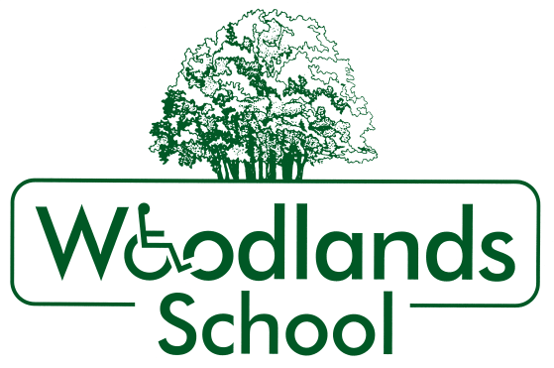 | FORTYFOOT ROAD  LEATHERHEAD  SURREY  KT22 8RY  Website:  www.woodlands.surrey.sch.uk
18th March 2020

Dear Parents and Carers

COVID – 19 School Closure

I am writing to tell you that I have taken the very difficult decision to close the school to pupils as of tomorrow (19th March) until after the Easter holidays. This will mean that today is the last day for pupils.

There are three main reasons for doing this:
- Firstly, the guidance from the government on social distancing for vulnerable people states that anyone who falls into the vulnerable category, should be following the social distancing advice, which includes limiting social contact in all areas.
- Secondly, we are unable to maintain a safe environment because due to the nature of the needs of our pupils, we cannot implement the 'social distancing' in class or maintain the hand/mouth/nose hygiene and as a consequence we cannot break the transmission of the virus within the classroom or school environment, therefore putting both pupils and staff at risk.
- Thirdly, the guidelines for self-isolation of 14 days for people who have symptoms within their families, means that a large proportion of our staff are not able to come to school. Because of this, we will be unable to safely manage staffing levels in the coming week.

This decision has not been taken lightly as we know that this is going to be a very difficult time for our families, but we hope that you understand that we are acting in the best interests of the pupils.
The staff have been working very hard to put together packs of activities that you can do with your child at home if you would like to. There is absolutely no pressure on any family to do this, they are just ideas for you to do if you choose. The class teacher will email all families each day, to give ideas of activities that you can do at home. Again, there is no pressure to do these, we do not want to add to parent stress at this time, but it may be useful to some. If you would like to, you can email your teacher back to give updates on how you are getting on.
We do ask that each family gets in contact with the class teacher, or replies to the email at least once a week, so that we can make sure you are OK. If we don’t hear from you, we will try other methods of getting in touch, or even pop around to check that you are well.
As long as they are well, staff will all continue to be working from home and will be doing everything we can to help. They will also be working on plans for the next term and making resources for class. Please email your teacher, Sarah (sarah.smith@woodlands.surrey.sch.uk) or Rosie (head@woodlands.surrey.sch.uk) if you are struggling or are having difficulties getting out to get supplies. We will try to help anyone we can.

We would like to be able to get any equipment that pupils may need home to you if possible. If you would like your child’s standing frame, walkers, chairs etc. to be sent home, please email receptionls@woodlands.surrey.sch.uk by 10am tomorrow morning and we will try to make arrangements to transport it.
We want everyone to know that we are thinking of you all and understand how difficult this will be. We will give you further updates by email and text about when we will reopen, following government information and guidelines as they come out.
We are sorry again to bring you this news but we hope you understand our decision.
Yours sincerely
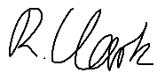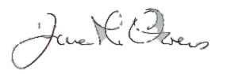
Rosie Clark Jane Owen
Head Teacher Chair of Governors

