Home Learning Week beginning 15/6/20
These are activities for the week you can pick and choose and do what you like when you like!
Literacy :
Working with words, letters and sounds
Our letters this week are:
W https://www.youtube.com/watch?v=MbUIYnDZZ-M&t=10s
X https://www.youtube.com/watch?v=RX9Pm9qj_QY
Y https://www.youtube.com/watch?v=L8PdL8ydI28&t=2s
Z https://www.youtube.com/watch?v=-TV4QpjgCE4 A https://www.youtube.com/watch?v=gsb999VSvh8&t=2s

Don’t forget to practise writing the letter and finding words beginning with the letter in PODD books/PODD devices/Eye gaze, or objects around the house.
Independent writing
You can use any photographs, pictures or objects that your child might find interesting as a stimulus for independent writing.
Use the alphabet page in their PODD books/PODD devices/Eye gaze or keyboard page to choose letters and create words or sentences about their chosen topic. Make sure that they choose letters to write their name on their work.

Book
We’re reading this week “I went to the zoopermarket” this week here is a link to it on youtube:
https://www.youtube.com/watch?v=clLWALyMhIk
What would you buy?
Finish the sentence I bought some…..

Make an Alphabet Books About Things I Really, Really Like!

This week make a book about your favourite fruits !
You can use paper and pen (and stick on photos or Google Images), book making apps such as Pictello or Book Creator, or online book making sites such as tarheelreader.org. You can also use cheap photo albums and put a small piece of paper on the photo that has the sentence.
1) Create a page for each of their favourites. You do not have to do the whole alphabet; just put the pages in alphabetical order. It is ok if the book only has four pages! The most important thing is that your child is learning that letter of the alphabet is important because it is used to write the name of this thing I love!
2) Read the books often. Reading can look like just looking at the photos and talking about the pictures, not reading the words on all the pages, or just flicking through to find your special favourite page!
3) When you read the books, use your child’s communication system to comment on the pages, talk about the pictures, or simply say ‘let’s turn the page for MORE’.
4) Talk about special letters during the day.

Art activities:
Paper plate monsters Paper plate Max
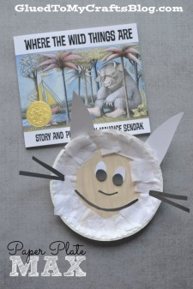
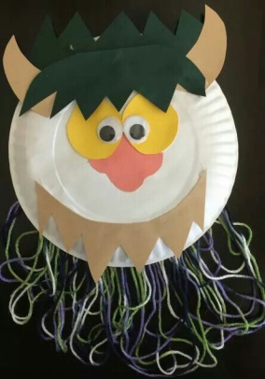

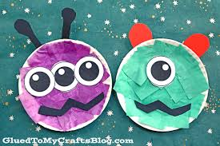
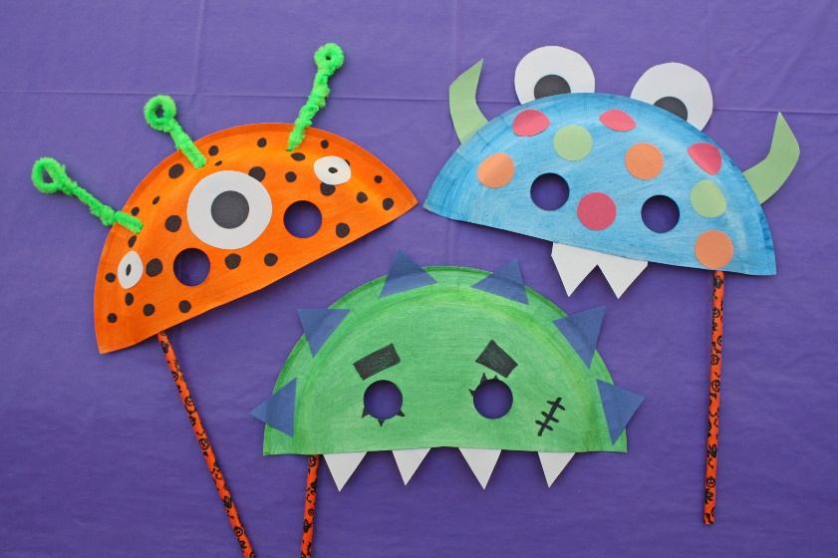

Get the paper plates out and get sticking, choose colours and shapes and stick where they place them!

Science Activities
- Play animal sound lotto and match animals to sounds.
- Compare real living animals with stuffed furry toys for alive/not alive, warmth, respiration, wet/dry, sounds/no sounds, movement/no movement, food/no food.

Animal guessing games:
https://www.youtube.com/watch?v=ucuXAYMYttc
https://www.youtube.com/watch?v=it3HGJBTX-4

RE Activities
- Watch the powerpoint ‘Mosques of the world’ and listen to the call to prayer (attached)
- Look at the powerpoint ‘Introduction to mosques’ (attached)

- Prayer beads – make prayer beads by finding beads, pasta or anything else to thread onto string. Strings of beads are hung around the mosque and help worshippers think of Allah

PE Activities:
Warm up song https://www.youtube.com/watch?v=MugzDjGDYjo&t=16s

Let’s get outside and do a nature scavenger hunt!

Use what outdoor equipment you have at home – trampolines, swings, bikes, walkers, scooters, etc and be active!

PE Sensory Circuit
1) Trampoline, bouncing on an exercise ball, running or a brisk walk, Jumping Jacks.
2) Balance beam, Stepping Stones, crawling through tunnels, balancing on a wobble board, Simon Says, using a scooter, throwing bean bags at a target, posting items, shape sorters.
3) Ball squash, steam roller, pressure e.g. weighted blankets, wall press ups, material tunnels, head massages, deep pressure massage.
Have all the equipment ready for all three parts before you begin.

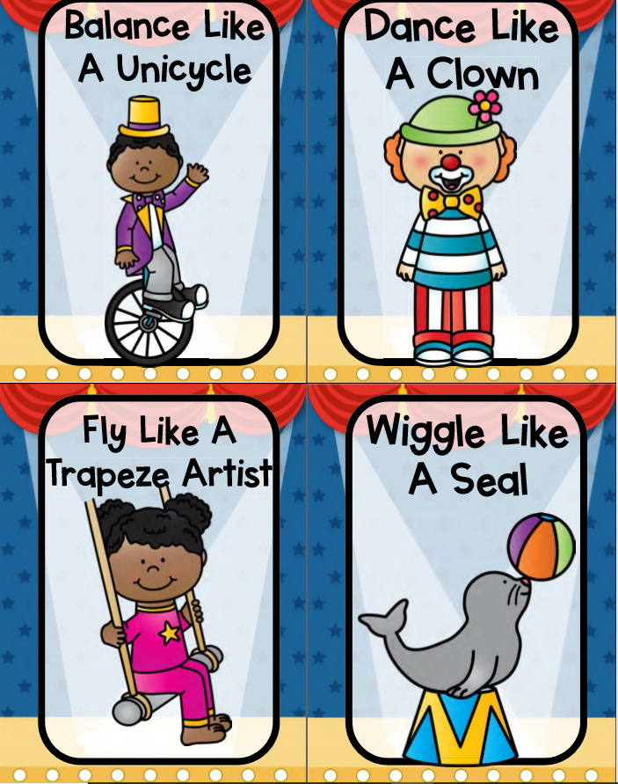
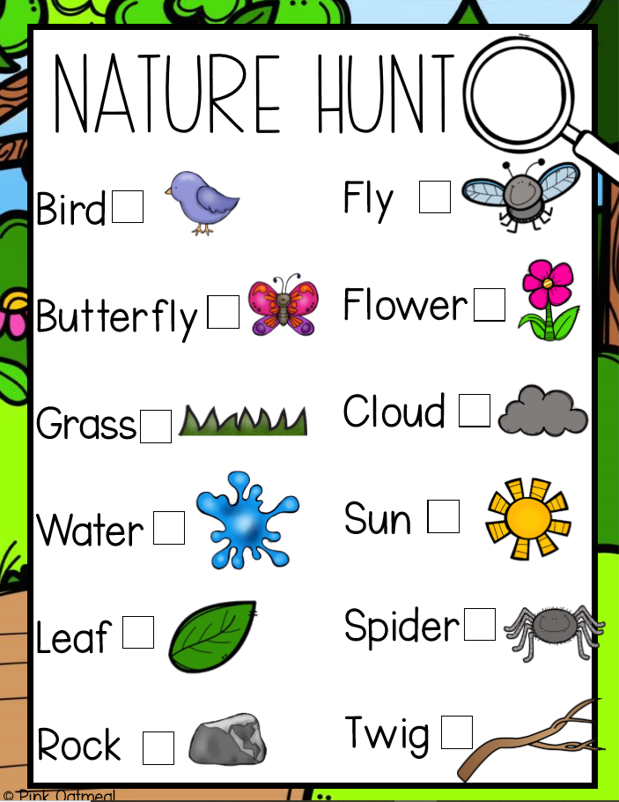

Maths activities:

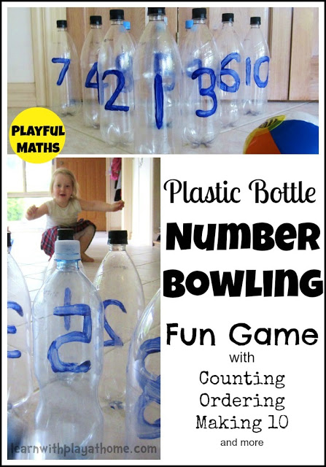
Mix it up by trying a variety of different balls. Which type of ball is best for knocking them all down?
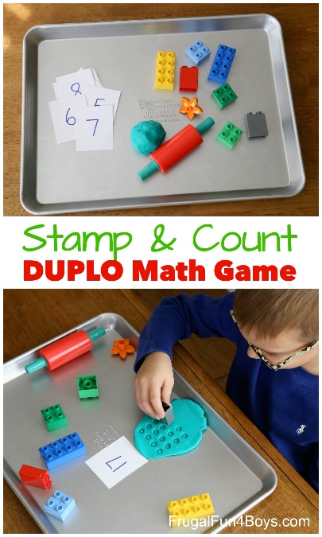

Stamping different size duplo or lego bricks in playdough is fun – lots of counting opportunities
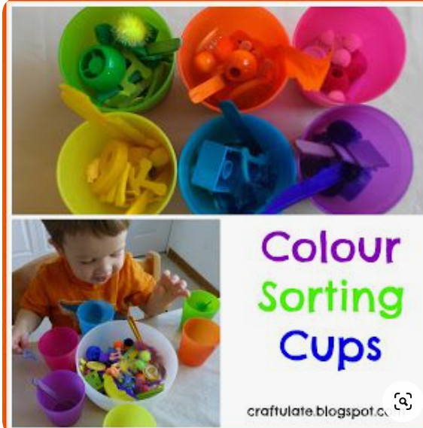
Sort a mixture of different coloured objects into coloured bowls /cups
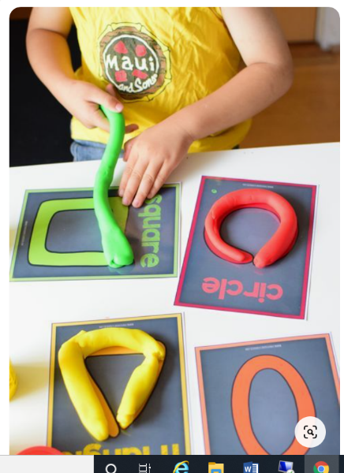
Playdough shapes

Take care. Have fun!

