Home Learning Week beginning 20/7/20
Here are some activity ideas for the week ahead and the summer holidays you can pick and choose and do what you like when you like!
Literacy :
Working with words, letters and sounds
Keep working with Letter of the day!
Attached is a Bounce Patrol alphabet link sheet for easy access!
Don’t forget to practise writing the letter and finding words beginning with the letter in PODD books/PODD devices/Eye gaze, or objects around the house.
Independent writing
You can use any photographs, pictures or objects that your child might find interesting as a stimulus for independent writing.
Use the alphabet page in their PODD books/PODD devices/Eye gaze or keyboard page to choose letters and create words or sentences about their chosen topic. Make sure that they choose letters to write their name on their work.

Book
We’re reading “Monkey and me,” this week there is a ppt and video on the school website you can access it here:
https://woodlandssurrey.primarysite.media/playlist/books

There are some Summer craft activities to look at in this week’s folder to keep you busy and here’s a Summer holiday bucket list – I wonder how many you can tick off!!
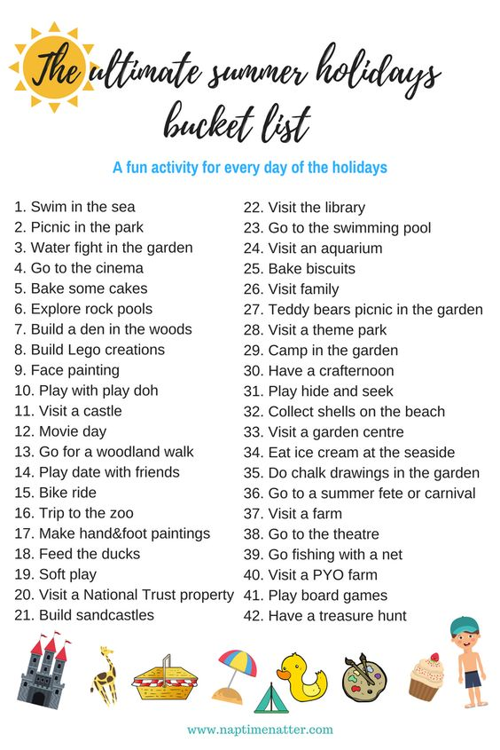
Take care. Have fun! See you in September! Ruth x

