Home Learning Week beginning 22/6/20
These are activities for the week you can pick and choose and do what you like when you like!
Literacy :
Working with words, letters and sounds
Our letters this week are:
B https://www.youtube.com/watch?v=kzzXROKd-i0&t=3s
C https://www.youtube.com/watch?v=1dhzPuT6jm0&t=10s
D https://www.youtube.com/watch?v=nb8DqaQmNWg&t=2s
E https://www.youtube.com/watch?v=beaUUPPUT2Y&t=9s
F https://www.youtube.com/watch?v=Zrj0feSC5oo&t=7s
Don’t forget to practise writing the letter and finding words beginning with the letter in PODD books/PODD devices/Eye gaze, or objects around the house.
Independent writing
You can use any photographs, pictures or objects that your child might find interesting as a stimulus for independent writing.
Use the alphabet page in their PODD books/PODD devices/Eye gaze or keyboard page to choose letters and create words or sentences about their chosen topic. Make sure that they choose letters to write their name on their work.

Book
We’re reading this week “Flying Lemurs.” Katie has done a video on the school website you can access it here:
https://woodlandssurrey.primarysite.media/playlist/books
What page do you like best?

Finish the sentence Lemurs are good at….

Make an Alphabet Books About Things I Really, Really Like!

This week make a book about your favourite colours !
You can use paper and pen (and stick on photos or Google Images), book making apps such as Pictello or Book Creator, or online book making sites such as tarheelreader.org. You can also use cheap photo albums and put a small piece of paper on the photo that has the sentence.
1) Create a page for each of their favourites. You do not have to do the whole alphabet; just put the pages in alphabetical order. It is ok if the book only has four pages! The most important thing is that your child is learning that letter of the alphabet is important because it is used to write the name of this thing I love!
2) Read the books often. Reading can look like just looking at the photos and talking about the pictures, not reading the words on all the pages, or just flicking through to find your special favourite page!
3) When you read the books, use your child’s communication system to comment on the pages, talk about the pictures, or simply say ‘let’s turn the page for MORE’.
4) Talk about special letters during the day.

Art activities:
Jungle snakes
You need a card template, some wool or material strips and some googly eyes (Or stickers!)
Wrap the wool/material round and round the template and stick on the eyes. You could make different sizes or a family of snakes!
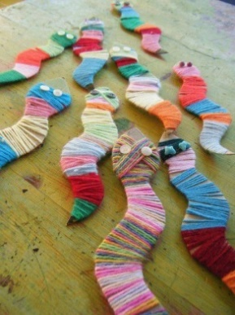

Science Activities
- Look at photos of animals and name main body parts.
Compare animal body parts and human body parts.
Lots of chat with PODD!
See photos and power point attached.

RE Activities
- Watch the powerpoint ‘Mosques of the world’ and listen to the call to prayer (attached)
- Look at the powerpoint ‘Introduction to mosques’ (attached)
- Islamic art printing - paint with potatoes! Cut potatoes in half and maybe even cut in a square or circle shape. Paint print with your potatoes to represent the repeated patterns in Islamic art that decorates mosques.
- Friday is Muslims’ holy day. Watch the days of the week song. https://www.youtube.com/watch?v=mXMofxtDPUQ

PE Activities:
Warm up song https://www.youtube.com/watch?v=MugzDjGDYjo&t=16s

Yoga week
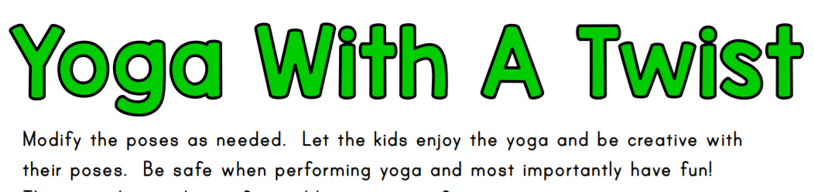
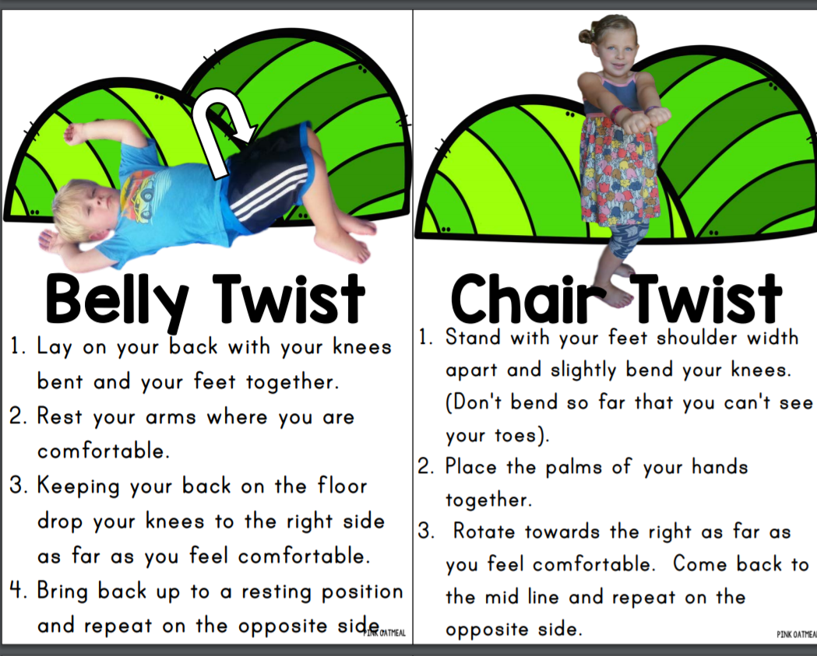

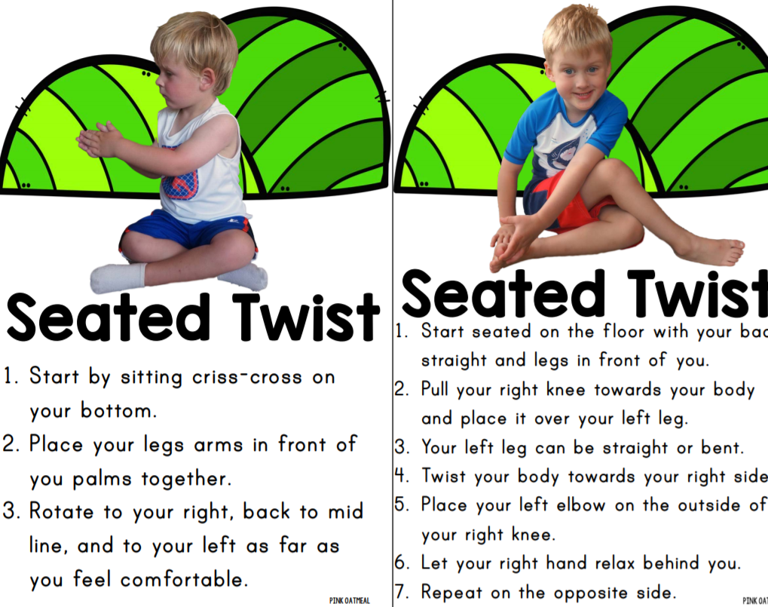
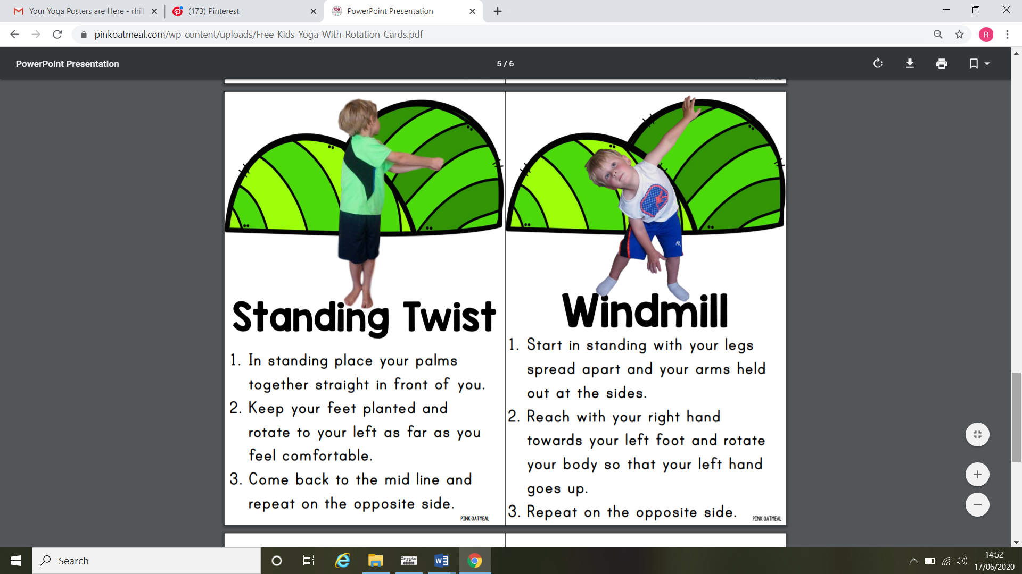

Maths activities:
- One or lots? Chat opportunities, sorting and matching games
You will need: pictures or photos of objects individually or in bigger groups (e.g. one mouth, a bunch of ﬂowers)
There are pictures attached if you want to print off or use the power point for discussion

- There are some good interactive games on the Topmarks site to try
https://www.topmarks.co.uk/maths-games/5-7-years/counting
- Lots on cbeebies too!
https://www.bbc.co.uk/cbeebies/topics/numeracy

Take care. Have fun!

