Foxes class – Weekly home learning
Week 3: Monday 15 June
Good morning activities
- Good morning song.
- Video is on the Woodlands school website (pupils – home learning)
- OR on YouTube - Good morning Mr Rooster https://www.youtube.com/watch?v=1Ziku4FLka4
- Sing and sign our alphabet
- Video is on the Woodlands school website (pupils – home learning)
- OR on YouTube https://www.youtube.com/watch?v=zKF97IQ4nV0
- Writing – children write their name each day using their alternative pencil (please see home learning pack for ideas on how to do this or contact Miranda or Katie for help and advice!)

Weekly literacy activities
Letter of the day
- YouTube bounce patrol song for the letter of the day
- Navigate to letters page on PODD
- Go on a letter hunt around the house finding things beginning with the letter of the day
- Can you think of any animals that begin with this letter?

Story of the week
- ‘I went to the Zoopermarket’ - find this at pupils / home learning / VRC section / Books. There is also a video version of this book in the home learning section.

Friday photos
Let your child choose a picture of themselves – maybe doing one of the activities from this week!
Use PODD to describe the picture. Write down whatever your child points to in PODD – there are no right or wrong answers! If you want, you could print out the photo and scribe what they choose to write underneath.
Monday | Letter of the day: I  Read: To find out what a zoopermarket sells  Write: Finish this sentence ‘I bought some…’
Tuesday | Letter of the day: J  Read: To find out how many items he bought  Write: Write a shopping list of everything you would buy
Wednesday | Letter of the day: K  Read: To find out what you would not want to buy  Write: About how the book makes you feel
Thursday | Letter of the day: L  Read: To find out the funniest joke in the story  Write: About your favourite animal in the story
Friday | Letter of the day: M  Read: To choose your favourite food in the story  Write: About your favourite food in the story
Maths | One to one matching  This week in maths, we are looking at one to one matching. You can find all the resources in the Foxes home learning section of the website in the ‘Maths’ folder.  - Sing with your child, ‘5 little speckled frogs’, counting as you go.  https://www.youtube.com/watch?v=fF32P24lUCA  - Navigate to the numbers page in your PODD book.  - Play the song again and pause at different stage. Count how many frogs. One jumped off, one less is….? Use PODD to reinforce.  - Use the PowerPoint to count how many frogs are on the log.  - How many frogs are in the pond?  - Complete this sentence, ‘In the pond are……’ | Resources  Powerpoint  - Maths Summer 2

Art  Monsters | Plate monsters  In Art this half term, we are going to make a range of monster crafts! You can find all the resources in the Foxes home learning section of the website in the ‘Art’ folder.  - Listen to the Monster shuffle  https://www.youtube.com/watch?v=vj9VwxrqvG0  - Talk with your child about how monsters move  - QUESTION – How do monsters make you feel?  - Finish this sentence ‘I feel…..’  - Cut out a round piece of cardboard or if you have a paper plate.  - Look at different animals and look at horns, trunks, noses.  - Have a go at making your own funny monster face! What could you add?  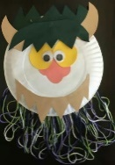  - Tidy up song https://www.youtube.com/watch?v=gPq7wzGEjqE | Resources
PE | Why not have a go at some physio, yoga or PE activities.  - YOGA – (you can find this in the Foxes home learning section of the website)  - PE – choose one or more of the following to do with your child  - Hokey cokey on Youtube  https://www.youtube.com/watch?v=YAMYsNe7DMQ  - Shake your sillies out (youtube or woodlands website, pupils – home learning) https://www.youtube.com/watch?v=03zqJQJRLN0  - Musical statues  https://www.youtube.com/watch?v=QJbvpcJSkbI | Resources  YOGA video
History  Celts | Celtic food  This week in History, we are looking at the food the Celts ate – they grew, hunted and gathered a wide range of food. You can find all the resources in the Foxes home learning section of the website in the ‘History’ folder.  - Can you make a fire together? Find some twigs and grass and add coloured red, orange and yellow paper for your fire. Put a saucepan on your fire and find anything you can for a tasty Celtic stew!  - Why not help cook a real Celtic stew? Look at the recipe in the Foxes home learning section of the website.  - Celts loved porridge – yum! Do you have any porridge or other cereal you could make / eat? What could you add to it? Celts loved honey!  - What sort of food did the Celts eat? Have a look at the ALD (Aided Language Display) sheet in the home learning section. How many of these foods do you have at home? Do you like them??  - EXTENSION – Look at the resource ‘What did Celts eat and drink?’. Can you have a go at sorting the foods?  - Relook at the resources from previous lessons on Celtic lifestyle | Resources  Celtic stew  ALD Celtic food  What did Celts eat and drink?  Resources from previous lessons

Music  Playing in time | Playing in time  In music this half term, we are learning about playing in time. The activities are a mixture of responding, interacting and performing. Some of these activities will be repeated each week – notice how your child’s ability to listen and interpretation of the music changes!  - Listen to the ‘Loud and quiet’ song https://www.youtube.com/watch?v=-xR5CXzxyMA  - Read the story ‘Wake up Mummy Bear’  - Listen to a nursery rhyme ‘I hear thunder’ (Cbeebies on Youtube) and tap or clap along. https://www.youtube.com/watch?v=lCPJhybHBkA  - Find objects around the house that you could use to make different sounds. Maybe make a video on your phone?  - Play musical chairs and stop when the music stops  - Play a piece of classical music with a regular beat:  Brahms - Hungarian Dance No.5  - Piano version:  https://www.youtube.com/watch?v=HCDygl0pttM  - Orchestral version:  https://www.youtube.com/watch?v=3X9LvC9WkkQ  - Which instruments can you hear played? Us the musical instruments page in PODD to choose. | Resources  Powerpoint  - ‘Wake up Mummy bear’
Science  Savanna | Savanna vegetation  In science, we are studying the savannah ecosystem. This week, we are looking at the plants you might find in the savannah. You can find all the resources in the Foxes home learning section of the website in the ‘Science’ folder.  - Look at the powerpoint ‘Savanna’  - Listen to some savannah songs from Youtube!  - This is the Savanna – PinkFong  - The Kidboomers - We're going on a lion hunt  - Hakuna matata - PinkFong.  - Play – can you take your savanna animals outside to play in the grass? The savanna is made of grasslands.  - Make a baobab tree out of junk modelling. Baobab trees have really thick trunks to store water.  - Look at some photos of baobab trees on google  - Use a toilet roll or anything else you can find to make your own baobab tree. Maybe add some twigs to the top!  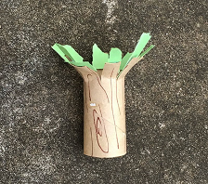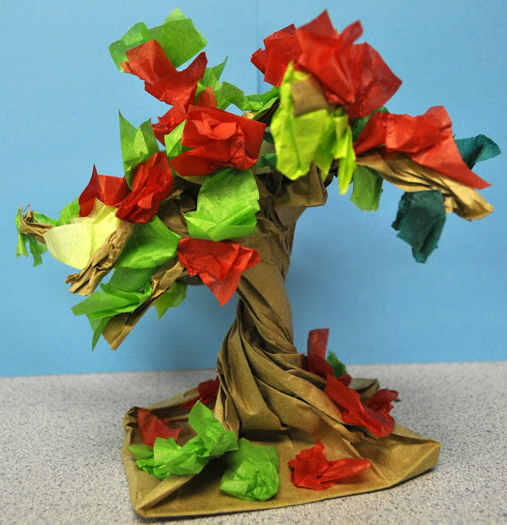 | Resources  Powerpoints  - Savanna
PSHE  Pets | Pet shop  In PSHE, we are thinking of how we care for our pets! You can find all the resources in the Foxes home learning section of the website in the ‘PSHE’ folder.  - Listen to the Super Simple song on Youtube – ‘I have a pet’  https://www.youtube.com/watch?v=pWepfJ-8XU0  - Look at the powerpoints on pets from previous lessons  - Read the story ‘Lola gets a cat’  - Why not set up a pet shop at home for role play?  - Collect as many toy animals as you can and make them each a bed.  - Decide your opening times and make an open/closed sign for your shop  - Label the pets with their price.  - Now it’s time to play! Which animal will you buy? | Resources  Powerpoints x4  - Photos of pets  - What can you see?  - What am I?  - Story – Lola gets a cat

