Badgers Class: Week beginning 29th June 2020
Theme: Holidays Main focus: Beach holidays
Suggestions for this week’s home learning activities. Please feel free to do as much or as little as you would like.
Area of learning:
Communication & Language | Use our Holidays theme to extend vocabulary. Use a range of communication methods, such as objects of reference, touch cues, symbols, signs, PODD books and spoken language.  Attention Bucket: Use a variety of highly motivating toys to develop attention, turn taking, commenting and requesting.  See: https://woodlandssurrey.primarysite.media/media/bucket
Literacy | Shared reading: Little Kipper’s Sandcastle  Shared writing: Sentence starter: ‘Sand feels…’  - Write the sentence starter at the top of the page  - Encourage children to select a symbol or look at the story to find something that describes the feel of sand. Use this to complete the sentence ‘ Sand feels…’. If possible, give children some real sand to explore.  - Each take a turn to identify something that describes the feel of sand (always beginning with the sentence starter, ‘Sand feels…’)  - When everyone has had a turn, read the sentences aloud.  Resources:  ‘Little Kipper’s Sandcastle’ PowerPoint in Badgers Home Learning section of Woodlands website.  ‘Sand feels… ’ pdf in Badgers Home Learning section of Woodlands website (this has also been assigned to all pupils on their Boardmaker Online account).  Independent writing: Provide opportunities for independent mark making every day. Use a range of writing tools, e.g. pencils, chalk, crayons, paint, using fingers, etc.  Letters of the day (with links to Bounce Patrol song):  C: https://www.youtube.com/watch?v=1dhzPuT6jm0&t=10s  G: https://www.youtube.com/watch?v=0KXtxIiQ7gk&t=13s  X: https://www.youtube.com/watch?v=RX9Pm9qj_QY  I: https://www.youtube.com/watch?v=P56hZEhqFCw  A: https://www.youtube.com/watch?v=gsb999VSvh8&t=2s  Letter work: Explore the letters of child’s name in rice, sand, flour, etc. Encourage children to find the initial letter of their name.
Maths | Shape, Space and Measure: Making ice lollies: Adults to support children to make their own ice lollies (if moulds are available) or flavoured ice cubes.  Resource: ‘Ice Lolly recipe ideas’ pdf in Badgers Home Learning section of Woodlands website.  Number:  - Number games at: https://www.topmarks.co.uk/maths-games/3-5-years
Understanding the World | Watch:  Sights and Sounds of the English Seaside: https://www.youtube.com/watch?v=q-Nvz2kEGvs  Magic Door – Beach Holiday: https://www.youtube.com/watch/V=s093m1tW9yo
PSED | Work on independent feeding skills.  Work on dressing skills.  Work on toilet training.
Physical Development | - Play balloon volleyball. This can be done sitting or standing, indoors or outside.  - Play in the sand or water tray. Focus on pouring from one container to another with minimal spillage.
Expressive Arts and Design | Make and decorate cardboard ice lollies: Children to select the card colour they would like. Adult to cut card into an ice lolly shape and attach a lolly stick to the back using glue or tape. Children to use glitter, paint, stickers, pompoms, etc. to decorate their ice lolly.  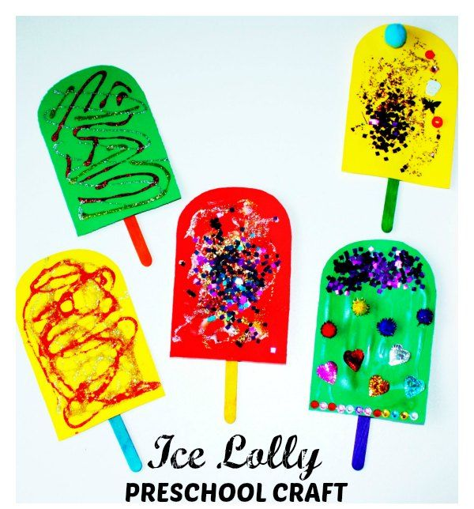  Make a seaside in a bottle:  Resource: ‘Seaside in a Bottle craft instructions’ pdf in Badgers Home learning section of Woodlands website

