Squirrels Class-Week beginning 29th June 2020
Suggestions of some home learning activities. Please feel free to adjust to suit your child.
Area of learning:
Literacy  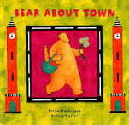 | Book: Bear About Town by Esther Sarfatti and Stella Blackstone  YouTube link: https://www.youtube.com/watch?v=jNLbc_WGInU  Shared reading: Follow the CAR (Comment and wait; Ask for participation and wait; Respond by adding a little more) and CROWD (Completion, Recall, Open-ended, Wh-, Distancing).  Shared writing:  Step 1:  Write a sentence about the book using the sentence starter: 'On Saturday, I go to the…' Take turns to write sentences. Write your name at the end of your sentence. Try to think about the letters in the word you want to spell.  Step 2:  Read through your sentences. 'On Saturday, I go to the…' Look for your names at the end of your sentence. Try to think about the letters in your name.  Step 3:  Ask your child to cut up their sentences between each word. Or scan the sentence with a pair of scissors and look for any attempt your child makes to communicate they want to make a cut in the paper.  Step 4:  Ask your child to stick the words down in a sentence and see what order they stick them in. Model how you would read the sentence.  Step 5:  Cut up the sentences you wrote and see if you can order them. Stick them in your book. Talk about how the sentences should sound.  Independent writing: Use your alternative pencil to write about something you are interested in and your name. Adults to present whole alphabet and go through letters one at a time, using a flipchart, PODD book or alphabet letters. Any attempt to select any letter of the alphabet is praised and encouraged and recorded by the adult/partner.  Independent reading: Choose a book of your choice and look at the pictures, Comment on the pictures and words. Turn the pages one at a time. Oxford Owl or Reading Eggs have some free e-books. Lilac band of Oxford Reading Tree are the ones we use the most.  Letters of the day: X, A, B, C and D. Focus on one letter a day. Use the Bounce Patrol videos to reinforce the letter.  Letter work: Download and use the Magnetic ABC app to move letters around and spell words. See if you can find the beginning and end letters for three letter words.
Maths  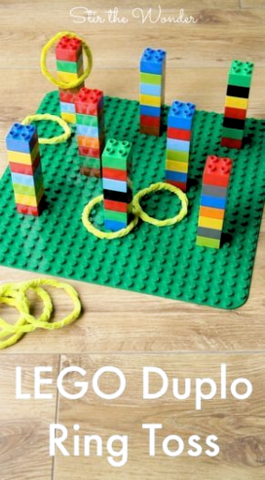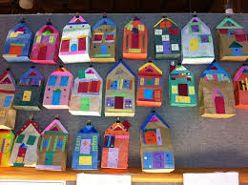 | - Boardmaker Online activities and Number songs  - Use the numicon and number line to count objects around the house/garden  - Functional maths skills at home  - Ideas for Maths Outdoors  - Try some free number games on abcya.com-https://www.abcya.com/grades/prek/numbers  - Read the maths story-Rosie’s walk on the website.  - Make model houses uses big and small boxes-find or make furniture to go in the big and small houses. Can you match the big furniture to the big house and the small furniture to the small house?  - Use duplo or lego to build different towers of different number blocks. Use playdough rolled into a ring or a hairband to throw hoops. Talk about a number and throw the hoop to land on the correct tower with that number of blocks.
Science  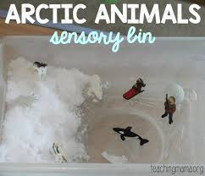 | Topic: Habitats  Intent: Pupils will explore, identify and group what animals live in the artic  - Listen to sounds of different arctic animals; whales, seals, polar bears, arctic owl  - Look at pictures/videos of different animals  - Group animals in the Arctic that would live in the sea (whale), and those that live on land ( Arctic fox, owl )  - Identify a feature of an Arctic animal ( flippers/fur )
PSHE  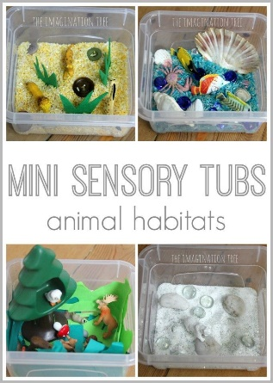 | Topic: Living in the Wider World-Saving our planet  - Read the George saves the world story book on YouTube- https://www.youtube.com/watch?v=i6xdwpgFWd0  - Predictable Chart Writing- ‘Our world is….’  - Choose different environments and set up play with animals – savannah, oceans, arctic etc
PE  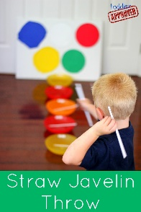 | Topic: Athletics  - Throwing for distance games- Straw Javelin Throw Game  Set up 4 bowls and use drinking straws as javelins to throw. Take turns to throw your javelin and see how far it goes. Award points to the bowls: nearest bowl being the least point and the furthest away bowl being the most points.
Art  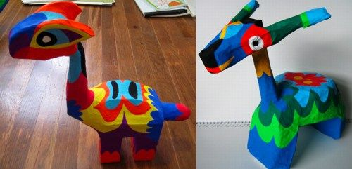 | Topic: Imaginary Places  Continue to create your own imaginary creatures using art materials, glitter, paint, tissue paper and paper mache.
Music | Topic: Composition  - Watch kids Zumba. Copy all the moves. Move to the beat with your head or hands.  - Compose a poem about town life (maybe you could write a sentence each using PCW) that you can put to music.  - Compose music for your poem.

Suggested Timetable
Monday | Tuesday | Wednesday | Thursday | Friday
Literacy | Literacy | Literacy | Literacy | Literacy
Maths | Maths | Maths | Maths | Maths
Science | Art | PE | PSHE | Music

