ELMWOOD CLASS - Home Learning Activities for Week Beginning 29th June 2020
 |  | Monday | Tuesday | Wednesday | Thursday | Friday
English  Focus Text for the week:  Fatou, Fetch the Water |  | Letter of the Day: N  https://youtu.be/hCxv2ZPU3vg  Shared Reading:  Read the book to find out who Fatou is.  Independent Writing:  Encourage your child to select an illustration to write about.  Or  Write a simple character description for Fatou. | Letter of the Day: M  https://youtu.be/YiK7IL0kqd0  Shared Reading:  Read the book to find out where Fatou went.  Independent Writing:  Encourage your child to select an interesting page from the book to write about.  Or  Write a list of objects Fatou is given during her journey. | Letter of the Day: D  https://youtu.be/NqntSJGu1t0  Shared Reading:  Read the book to find out why Fatou didn’t bring the water to her Mother.  Independent Writing:  Research and have a look at pictures of colourful African clothes and materials and write about them. | Letter of the Day: G  https://youtu.be/ru0KCAS5zuY  Shared Reading:  Read the book and use some descriptive words to talk about the African Village Scene.  Independent writing:  Label an interesting page from the book with names of objects, animals and characters. | Letter of the Day: O  https://youtu.be/_wc44BGQWF0  Shared Reading:  Read the book then talk about what it might be like to be a child in an African village.  Independent writing:  Encourage your child to write about an activity they enjoyed over the past week. You might like to use photographs or objects as stimulus for writing.
Maths | Counting &  Comparing quantities | Count and Move  https://www.youtube.com/watch?v=Aq4UAss33qA  Counting objects up to 5 / 10  Count a variety of objects up to 5 / 10 or more as appropriate. Use items, you have in your home for example pasta shells, apples.  Counting out a given number of objects  Show your child /write a numeral up to 5 and encourage them to count out the correct number of objects. You could use lego blocks etc, you could also link colour to groups of objects. | Count and Move  https://www.youtube.com/watch?v=Aq4UAss33qA  Counting objects up to 5 / 10  Count a variety of natural objects found in your garden or local area e.g. lamp posts, cars, trees.  Counting out a given number of objects  Show your child /write a numeral up to 5 and encourage them to count out the correct number of objects. You could use lego blocks etc, you could also link colour to groups of objects.  . 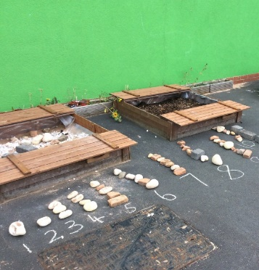 | Count and Move  https://www.youtube.com/watch?v=Aq4UAss33qA  Cut and Count dough shapes  Make a simple dough or using playdough you can roll into balls (Spheres) or cut into shapes.  Cookie number bonds to 5 or 10  If you can make cookies or similar that would be great. Add spoons of ingredients counting as you go.  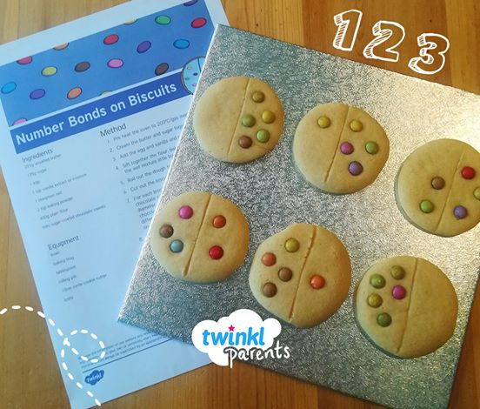  Count and place raisins, chocolate buttons or little sweets or treats onto your creations. Up to a number that you feel is appropriate for your child. | Count and Move  https://www.youtube.com/watch?v=Aq4UAss33qA  More or Less  Compare sets of objects using the language ‘more’ and ‘less’.  Some practical ideas might include:  Which plate has more raisins? Which plant has less flowers?  Which purse has more coins?  Which box has less eggs?  What fruit is there more of in the fruit basket?  More or Less Interactive Game  http://www.ictgames.com/mucky.html  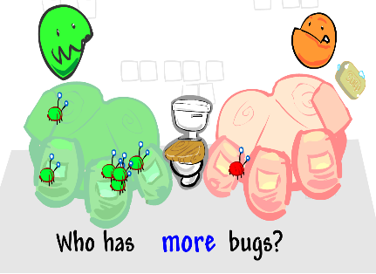 | Count and Move  https://www.youtube.com/watch?v=Aq4UAss33qA  Alligator more/less  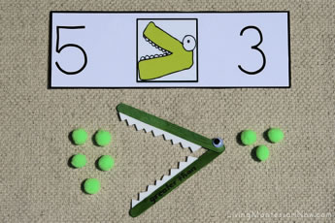  Alligator Song:  https://www.youtube.com/watch?v=ka9zbPcqXBI  Work through the activities to explore the concept of more/less:  http://resources.hwb.wales.gov.uk/VTC/greater_less_than/eng/Introduction/default.htm
Maths | Place Value | Count and Move  https://www.youtube.com/watch?v=Aq4UAss33qA  Count forwards and backwards to and from 20 and write numbers up to 20.  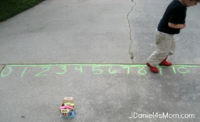  Complete the ‘Missing numbers’ worksheet. (attached) Alternatively, draw out your own number line on the ground using chalk or electronically using the computer. | Count and Move  https://www.youtube.com/watch?v=Aq4UAss33qA  Work through the ‘Partitioning Tens and Ones’ powerpoint (attached)  Have a go at partitioning two-digit numbers – see example below. 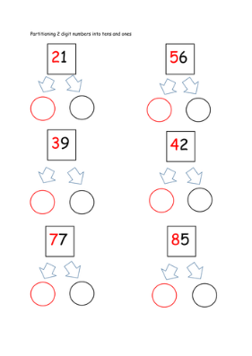 | Count and Move  https://www.youtube.com/watch?v=Aq4UAss33qA  Repeat yesterday’s powerpoint to recap partitioning tens and ones.  Practice partitioning some two-digit numbers.  Complete the worksheet attached.  Alternatively, select and play some games involving partitioning from the website below:  http://www.ictgames.com/mobilePage/placeValue.html | Count and Move  https://www.youtube.com/watch?v=Aq4UAss33qA  Introduction to place value:  https://www.youtube.com/watch?v=sepBmoXqYfc  Practice making different numbers using the place value cards  http://www.communication4all.co.uk/Numeracy/Place%20value%20cards.pdf  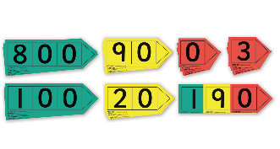  Interactive place value cards to make numbers:  http://www.ictgames.com/mobilePage/arrowCards/index.html | Count and Move  https://www.youtube.com/watch?v=Aq4UAss33qA  Interactive games involving partitioning and use of place value:  Shark numbers:  http://www.ictgames.com/sharkNumbers/mobile/index.html  A selection of place value games to choose from:  http://www.ictgames.com/mobilePage/placeValue.html  More place value games to explore:  https://www.topmarks.co.uk/maths-games/7-11-years/place-value
Wider Curriculum |  | Art  Impressionism  Please look at the painting  “Starry Night Over the Rhone” by Van Gogh.  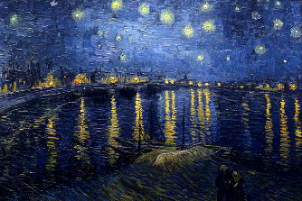  Talk about what you can see in the picture, the colours used and encourage your child to express an opinion (e.g. like/don’t like).  Encourage your child to create their own interpretation of the painting using their choice of art material available at home. | Science  Motion in the Ocean  Pupils will explore and identify endangered marine species.  Pupils will learn about marine conservation  Watch the following short video clips.  Keeping Plastic out of the sea  https://youtu.be/HQTUWK7CM-Y  https://youtu.be/xFPoIU5iiYQ  A Whales Tale – Hope Works  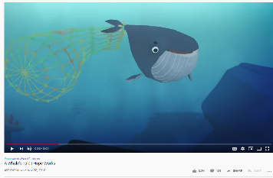  Do some further research to see what other issues affect our marine life and oceans.  Why not make a poster to highlight some of the key issues. Cut out images from magazines to show the types of products that end up in the sea. Or a poster to promote caring for our oceans and marine life. | PSHE:  Activities to Promote Positive Mental Health and Well-Being  Select some activities from Dr Amber Owen’s Mindfulness Activity Selection.  https://alderhey.nhs.uk/application/files/9815/8515/7280/Mindfulness_activities_for_kids.pdf  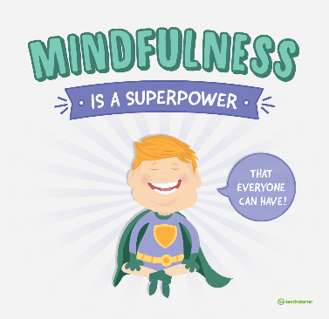 | DT / Food Tech  Topic:  To make foods connected to the sea, rivers or water. You might like to try one of the following:  - Tuna mayo sandwich  - Sesame prawn toast  https://www.bbcgoodfood.com/recipes/sesame-prawn-toast  - Fish cakes  https://www.bbc.co.uk/food/recipes/easy_kids_fishcakes_70996  - Fish fingers  https://www.kidspot.com.au/kitchen/recipes/healthy-fish-fingers-recipe/x0oepe2r?r=collection/seafoodrecipes&c=iua0ofqr/Seafood%20recipes  - Tuna Pasta Bake  https://www.bbcgoodfood.com/recipes/tuna-sundried-tomato-pasta-bake  - Prawn Cocktail  https://www.eatsamazing.co.uk/seasonal-fun-food/christmas/easy-prawn-cocktail-recipe  - Prawn Tempura  https://www.netmums.com/recipes/prawn-tempura  - Fish Nuggets  https://www.tasteofhome.com/recipes/oven-fried-fish-nuggets/ | Music  Listening: Encourage your child to listen to a variety of music with a water theme and encourage them to describe what they hear in simple terms.  - Water Music by Handel  - The Sea by Debussy  - The Moldau by Smetana  - Spring Waters by Rachaninoff  - The River by Schubert  - Still Waters by Tony Banks  - Yellow River by Xinghai  Interacting/Performing:  Make your own musical instruments using water. http://kiddley.com/2013/07/09/10-great-musical-instruments-to-make-at-home/  Use musical instruments available at home / instruments you have made or household objects to create water-like sound effects.
Health and Fitness |  | A selection of Yoga stories to work through: https://www.youtube.com/user/CosmicKidsYoga  A Tai Chi sequence for children you might like to try with your child: https://www.youtube.com/watch?v=YMVg5diOiMs&t=428s  PE with Joe Wicks: https://www.youtube.com/watch?v=zKhGfdSvG3s  Daily walk following current social distancing guidelines...

