Squirrels Class-Week beginning 6th July 2020
Suggestions of some home learning activities. Please feel free to adjust to suit your child.
Area of learning:
Literacy  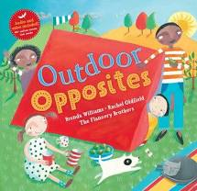 | Book: Outdoor Opposites by Brenda Williams  See Powerpoint story on website  Shared reading: Follow the CAR (Comment and wait; Ask for participation and wait; Respond by adding a little more) and CROWD (Completion, Recall, Open-ended, Wh-, Distancing).  Shared writing:  Step 1:  Write a sentence about the book using the sentence starter: 'I can…' Take turns to write sentences. Write your name at the end of your sentence. Try to think about the letters in the word you want to spell.  Step 2:  Read through your sentences. 'I can…' Look for your names at the end of your sentence. Try to think about the letters in your name.  Step 3:  Ask your child to cut up their sentences between each word. Or scan the sentence with a pair of scissors and look for any attempt your child makes to communicate they want to make a cut in the paper.  Step 4:  Ask your child to stick the words down in a sentence and see what order they stick them in. Model how you would read the sentence.  Step 5:  Cut up the sentences you wrote and see if you can order them. Stick them in your book. Talk about how the sentences should sound.  Independent writing: Use your alternative pencil to write about something you are interested in and your name. Adults to present whole alphabet and go through letters one at a time, using a flipchart, PODD book or alphabet letters. Any attempt to select any letter of the alphabet is praised and encouraged and recorded by the adult/partner.  Independent reading: Choose a book of your choice and look at the pictures, Comment on the pictures and words. Turn the pages one at a time. Oxford Owl or Reading Eggs have some free e-books. Lilac band of Oxford Reading Tree are the ones we use the most.  Letters of the day: E, F, G, H and I. Focus on one letter a day. Use the Bounce Patrol videos to reinforce the letter.  Letter work: Try a spot and dot worksheet. Use coloured markers or pencils to colour the corresponding letters.
Maths  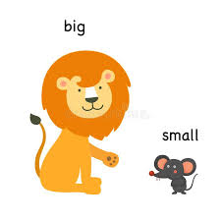 | - Boardmaker Online activities and Number songs  - Use the numicon and number line to count objects around the house/garden  - Functional maths skills at home  - Ideas for Maths Outdoors  - Try some free number games on abcya.com-https://www.abcya.com/grades/prek/numbers  - Use the Powerpoint to talk about big and small objects  - Play a big and small hide and seek game-open your eyes is it a big or small object?  - Draw numbers on the floor and play hopscotch with beanbags
Science  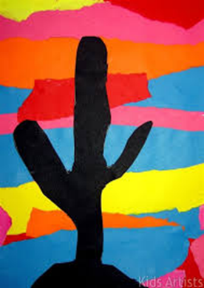 | Topic: Habitats  Intent: Pupils will explore, identify and group what animals live in the desert  - Listen to sounds of different desert animals; camel, lizard, lion, snake.  - Look at pictures/videos of different animals  - Sort animals into those you would expect to find in desert and those you would not  - Explore sensory sand tray and write animals names  - Desert sunset art
Geography | Topic: Place knowledge- Town and Countryside  - See the geography powerpoint on website  - Look at the pictures of towns-what can you see?  - Listen to the sounds of the town  - Look at the pictures of the countryside-what can you see?  - Listen to the sounds of the countryside  - Sort the pictures between town and countryside
PE  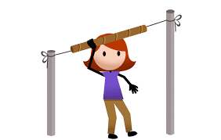 | Topic: Athletics  - Throwing for distance games- Cardboard Javelin  - Start by running the string through a cardboard tube. Next, tie the string to two objects (trees work well) so it is forms a straight horizontal line with the cardboard tube running along it. Children can then grasp the cardboard tube and see how far they can throw it along the line.
Art  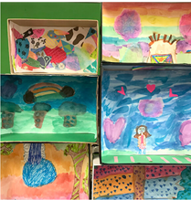 | Topic: Imaginary Places  Plan and create a tiny imaginary place in a small box  https://artfulparent.com/create-these-awesome-mini-worlds-with-shoebox-dioramas-for-kids/
Music | Topic: Composition  - Watch kids Zumba. Copy all the moves. Move to the beat with your head or hands.  - Compose a poem about country life (maybe you could write a sentence each using PCW) that you can put to music.  - Compose music for your poem.

Suggested Timetable
Monday | Tuesday | Wednesday | Thursday | Friday
Literacy | Literacy | Literacy | Literacy | Literacy
Maths | Maths | Maths | Maths | Maths
Geography | Art | PE | Science | Music

