Celtic soda bread
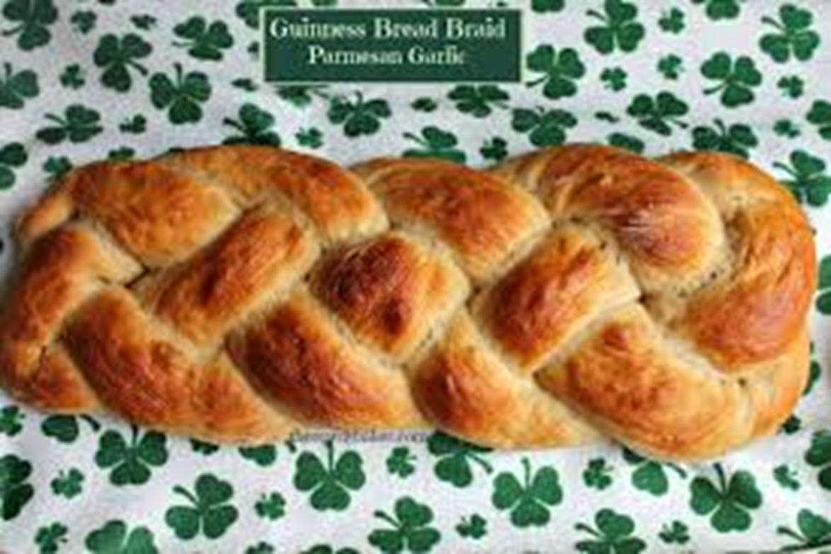

Ingredients
500g plain wholemeal flour
2 tsp salt
1 tsp bicarbonate of soda
1 tbsp finely chopped rosemary (optional)
400ml whole milk
1 lemon, juiced
2 tsp honey

Method

- Heat oven to 200C/180C fan/gas 6. Mix together the flour, salt and bicarb in a bowl. And if you’d like rosemary bread, add the chopped rosemary too.

- Mix together the milk and lemon juice in a jug, and wait for a minute as it magically turns into buttermilk. Then stir in the honey, and simply pour it into the flour mixture. Stir it with a knife for a minute until the whole thing comes together into a sticky dough.

- Tip onto a floured work surface and shape it into Celtic bread.

- Put in the oven and bake for 40 mins.

