County Care Services, Opportunities & Enterprises

Please see all of our new and ongoing services available at County Care for people with learning disabilities, autism and mental health. The principle of our Daytime Opportunities and our Community Skills Project is to develop independence, living skills, preparing and finding work, building confidence and giving constructive meaning to people's interests and passions. Junction 18 is aimed toward providing social and leisure activities, giving those we support the opportunities to mix with like-minded people and enjoy accessing the community. Here is breakdown of our services below:
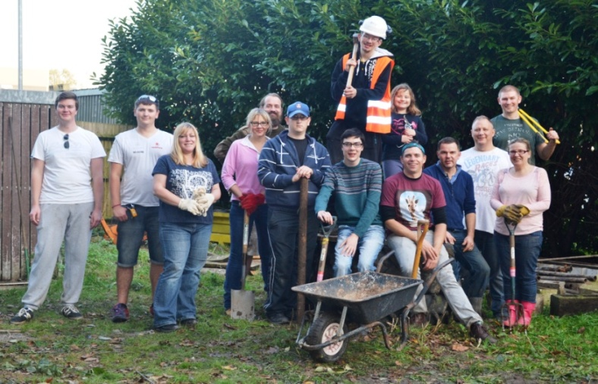
Community Skills Project (Previously called LED)
Where: HORLEY & WOKING
When: Runs five days a week 9am - 4pm Based at Horley Football Club

The Community Skills Project is for adults with learning disabilities and autism. It can be accessed on a full or part time basis. The goal is to provide the people we support to live purposeful, independent lives encompassing life, leisure and social skills from our base in Horley or Woking.

The programme includes a variety of learning experiences and activities designed to offer each individual the opportunity to:

- Learn transferrable life skills
- Gain a greater awareness of their local community
- Gain confidence and independence
- Enhance their physical abilities
- Develop their social skills & build relationships
- Explore new work skills

This is a example of the support we currently offer in our Horley Community Skills Project - other areas may differ.

 | 9-12 | 12-1 | 1-4
MON | Living with Technology |  | Healthy Life Styles (Diet, nutrition, fitness)
TUE | Mow-tivated |  | Mow-tivated
WED | Plan it, Buy it, Cook it: Menu planning, travel training & shopping |  | Plan it, Buy it, Cook it: Preparing, Food hygiene and cooking
THU | Pathway to Employment |  | Pathway to Employment
FRI | Organising My Life |  | Inter-Action (Social, fitness & confidence building)

Regardless of ability, it is important to us that the people we support have a voice and are encouraged to take a proactive role to ensure that what we are doing is relevant to them and their needs. Enterprise and work experience plays an integral role in our Programme. The aim of the Programme is to develop an understanding of the community and the roles within it.

Group size is limited to 12 placements with an appropriate staffing ratio dependent on individual needs. We can offer bespoke programmes to meet individual needs.
The programme runs for 48 weeks throughout the year – 9am – 4pm.

Daytime Opportunities:

Our aim is to support adults with learning disabilities to reach their full potential . We want to provide the tools for people to be able to empower themselves so that they feel in control and have a sense of belonging in their local communities relevant to them. Our goal is to provide people with the tools and skills. We are committed to helping individuals realise their potential and build self worth through meaningful and creative day-to-day activities. We are continuously developing new programmes and activities with people we support. All our activities are designed around individuals, building on existing skills with the aim to enable a more independent life.
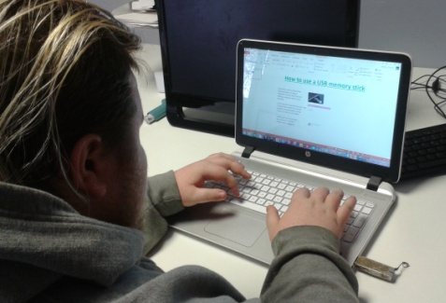
Office Project:

Where: HORLEY
When: Runs Wednesdays & Friday (Friday is a new day) 9:30am - 4:30pm at Gatwick House, Horley

We support individuals to run their own office-based social enterprise. Participants will be supported to run their own office, go to meetings & keep deadlines, work as a team to get commissions from the community, design graphic projects & flyers to promote to their clients, write CVs, letters, applications and using the phones, Use emails, Microsoft Office and the internet, build confidence with printing, scanning, photocopying, laminating & shredding.
___________________________________________________________________

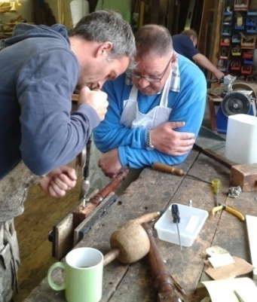
Furniture Project:

Where: REDHILL
When: Tuesdays and Thursdays (Thursday is a new day) 10am - 3pm at Dade's Antiques,
1 Fengate's Road, Redhill

We are in partnership with Ryan Harris; professional furniture restorer who is supporting practical carpentry skills and teaching furniture restoration in a working environment. Supervising use of tools and techniques; this has included participants building their own chairs, repairing chest of drawers and writing desks and restoring them to traditional period condition, designing making a number of different items to the finished article; bird boxes, newspaper racks, bedside tables etc.
___________________________________________________________________

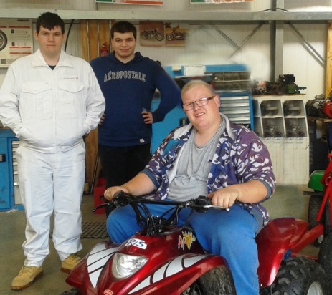
Motor Mechanics Project:

Where: ALBURY, near GUILDFORD
When: Mondays 9:30am - 2:30pm in Albury Sand Pit, between Guildford and Sheer

We have partnered up with a group of professional mechanics who support our guys to learn how work on vehicle engines at a pace that suits them and gain an accredited qualification. They have up until now looked at a number of different engine parts, have constructed a quad bike and built their own go-kart from scratch. They are now seeking to build their own soap-box vehicle to be used in the Red Bull Soap-Box Racing Event this summer.
___________________________________________________________________

Media Scene:

Where: SEND, near WOKING (looking to start in Horley soon)
When: Fridays 10am - 3:30pm at County Care Send Office

We are starting up a new exciting media-based scheme where participants will be running their own social venture. This will include photography, film making & editing, learning how to use media equipment & software, internet radio broadcasts & podcasts, creating newsletters, investigating current events & affairs and applying this to projects.
___________________________________________________________________

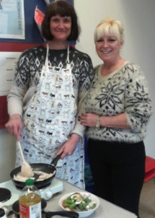
Ready, Steady, County Cook:

Where: CAMBERLEY & WOKING
When:
Tuesdays 10am-12:30pm at New Community Building, Woking (near Leisure Centre)
Fridays 1:30am-4pm at New Community Building, Woking (near Leisure Centre)
Fridays 1pm - 3:30pm at High Cross Church, Camberley

This cooking project is centred around improving independence and confidence to plan, prepare and cook realistic meals, similar to what one might cook at home. Participants will be compiling a book of tailored recipes that can be practiced and re-used at home, practicing food hygiene, learning about eating a healthy balanced diet, preparing and cooking everyday meals and cleaning up after themselves. The goal will be for people to gradually gain the skills to complete these tasks with increased independence so they can transfer these skills to real life.

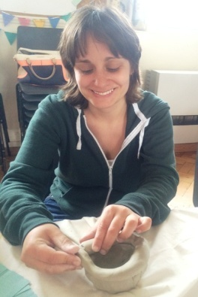
Pottery:

Where: WOKING
When: Thursdays 2am - 4:30pm at New Community Building, Woking (near Leisure Centre)

Working alongside professional artist and potter, Sarah Plunkett to support participants to work on ceramic and craft-based artworks. This makes this a therapeutic and sensory activity supporting participants to express themselves freely in a friendly atmosphere under expert tuition.
___________________________________________________________________
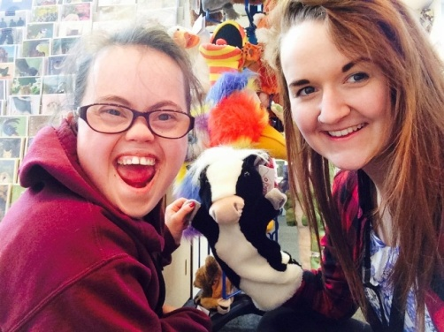
Acting Out:

Where: Woking
When: Mondays 2pm - 4pm at New Community Building, Woking (near Leisure Centre)

This is a new group we are starting in January 2015. It is specifically geared towards supporting social interaction, building confidence and teaching participants about building and maintaining appropriate relationships whilst having fun. Within the group those we support will be running their own drama production and developing leadership skills. They will be learning communication and performance techniques, working on literacy skills whilst writing their own scripts, designing and making their own costumes and sets and performing their own pantomimes, musicals and plays.
___________________________________________________________________

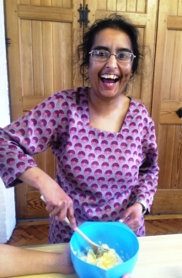
County Care Cafe Enterprise:

Where: WOKING
When: Wednesdays 10am-2pm at New Community Building, Woking (near Leisure Centre)

Help us run our very own Cafe Club and get experience and training - Dealing with customers and taking their orders, makings hot drinks, learning how to bake and decorate cakes, managing money skills in a cafe environment, setting up shop and clearing away, learning about food health and hygiene.

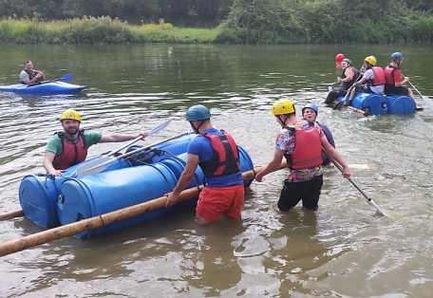
Bear Skills - Survival Group:

Where: WOKING & the surrounding area
When: Tuesdays 1pm - 4pm at New Community Building, Woking (near Leisure Centre)

Do you seek a challenge? Ever wanted to have an adventure? Well here your chance! Learn survival & outdoor skills in our New Community Building and out in the local area & beyond. Map work & Orienteering - Bike maintenance - Trekking & Camping - Bush Craft & Den Building - First Aid & Staying Safe - Kayaking & Cycling - Knot tying & Signalling - Raft Building & Fishing.
___________________________________________________________________

Job Squad:

Where: WOKING
When: Thursdays 10am-12:30pm at New Community Building, Woking (near Leisure Centre)
Under the guidance of a professional session worker, we will give motivation, information and training. We will match people up with interests and passions with what is out there, whilst being realistic about opportunities. We will support people to get into work experience placements, volunteering and aim to support paid employment. We will prepare you by helping you with:
- Your CV
- Job searches
- Filling out application forms
- Interview skills
- Self-Esteem & confidence
- Advice on the potential impact on benefits

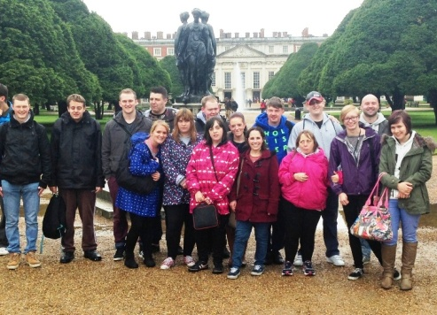
Discovery Society:

Where: WOKING
When: Thursdays 1:30pm-4pm at New Community Building, Woking (near Leisure Centre)

Interactive, educational sessions and trips with the focus on factual subjects for those who love to learn. We will be covering science, nature history & culture with guess speakers, trips to places of interest and linking up with local societies within the community. A great group to join to network with others in the local area, learn and have fun doing it.

Social & Leisure - JUNCTION 18:
Social, Leisure, Community Access and supporting activities and opportunities that others take for granted.


Bowling:

Where: WOKING, ALDERSHOT, CRAWLEY, CHARRINGTON, HEATHROW & GUILDFORD (For venues, please ask for more details)
When: Tuesdays 6:30pm - 7pm start for approximately 2 hours

We also run bowling leagues across venues in Surrey where you can meet up with friends, socialise and play a few games. We hold games every Tuesday and teams from different areas compare scores.
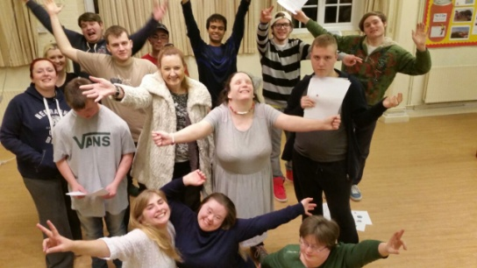
County Care Pop & Rock Choir:

Where: WOKING
When: Mondays 6:30pm - 8:30pm at St Mark's Church, Westfield Road, Woking

If you love to sing and want to be a part of something bigger, bolder and musical. It doesn’t matter what your skills are. Join our Pop & Rock Choir!


Meet & Eat:

Where: REIGATE, SHEPPERTON, GUILDFORD & CAMBERLEY (For venues, please ask for more details)
When: Monday once a month 7pm -9:30pm

We organise a fun night out once a month on Mondays, supporting people to socialise, meet with friends and order their meal and drinks! We also arrange our own regular quiz with a mix of easy to for challenging questions and picture rounds.
_________________________________________________________________________


H20 - Swimming:

Where: HORLEY
When: Wednesdays 1:30pm - 2:30pm at Horley Leisure Centre

H20 is a swimming group where you can gain confidence in the water, join friends and get fit. It is ran by fully qualified swimming instructors at the newly refurbished pool at Horley Leisure Centre with adapted wheelchair access into the water.
_________________________________________________________________________


Smash Up! Badminton:

Where: HORLEY
When: Mondays 2pm - 4pm at Horley Leisure Centre

Smash Up! is a modern ‘mashed up’ mix of big hitting badminton challenges, mates and music. Get fit, gain confidence and socialise with our trained coach.


Multi-Sports

Where: WOKING
When: Wednesdays 2pm - 4:30pm at New Community Building, Woking (near Leisure Centre)

Come and join us with trained sports coach to try out a wide variety of solo & team sports like football, badminton, ping pong, boccia, kick-golf, gym training and more. Get fit, socialise and have fun whilst doing it!
_________________________________________________________________________

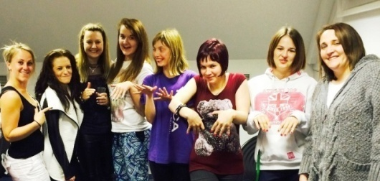
Girl's Night In:

Where: SEND (WOKING), HORLEY
When: Send - Last Wednesday of the month 6:30pm - 9pm
Horley - 3rd Wednesday of the month 6:30pm - 9pm (New Day)

Our Girls Night In is a time where our female service users can put their feet up, have a giggle and pamper themselves. Generally, this is a social gathering, where we will support different activities from manicures, arts & crafts, decorating and making cushions, getting a takeaway, watching movies and having a good chat.

Boy's Night In:

Where: SEND (WOKING), HORLEY
When: Send - 3rd Thursday of the month 7pm - 9pm
Horley (New Day) - 2nd Thursday of the month 7pm - 9pm

In a similar vein to our Girls Night; Boy's Night In is a social Night about lads being about to making friends, sharing like-minded hobbies and pastimes, like Card/Board/Video games, Music, Movies, Take out, Pool, Open Mic Night and Sports.


Mayhem Night Club

Where: WOKING
When: Once every 2 months on arranged nights

Every 2 months, Mayhem Night Club is open for people with learning disabilities. In support of this, we arrange for parties of people we support to attend, mingle, dance and socialise.
_________________________________________________________________________

Please note, that should a service user require additional support to attend our services this may incur additional costs. We will do our best to tailor individual's needs and would be happy to discuss this you.

For further details or to arrange a referral please feel free to contact:

Benjamin Kimberlee
Services Manager
County Care Independent Living Ltd

Horley Office: 01293 786117
Gatwick house, Suite 2A, Peeks Brook Lane, Horley, Surrey, RH6 9ST
Send Office: 01483 224183
Vine House, Walnut Tree Place, Send, Surrey, GU23 7HL
Mobile: 07876 834268
Email : benjamin.kimberlee@countycare.co.uk
Website: www.countycare.co.uk

