LO: To be able to colour half a shape.
Date: _________________________.

Can you colour in one half of the following shapes: ½

½ | ½ | ½ | ½ | ½ | ½
½
Write half in the spaces below.


Find halves of these quantities:
½ of 2 = ______

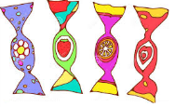
½ of 4 = ______

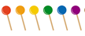
½ of 6 = ______


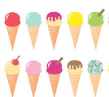
½ of 12 = ______

½ of 10 = ______

½ of 8 = ______

LO: To be able to colour half a shape.
Date: _________________________.

Can you colour in one half of the following shapes: ½

Practise writing ½

½ ____ ____ ____ ____ ____ ____ ____ ____ ____

½ of 4 = ______

½ of 6 = ______

½ of 8 = ______


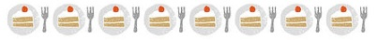
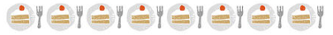
½ of 20 = ______

½ of 18 = ______

½ of 16 = ______

½ of 14 = ______

½ of 12 = ______

½ of 10 = ______

LO: To be able to colour half a shape.
Date: _________________________.

Can you colour in one half of the following shapes: ½

½ of 10 = ______

½ of 6 = ______

½ of 4 = ______

½ of 8 = ______

½ of 12 = ___________

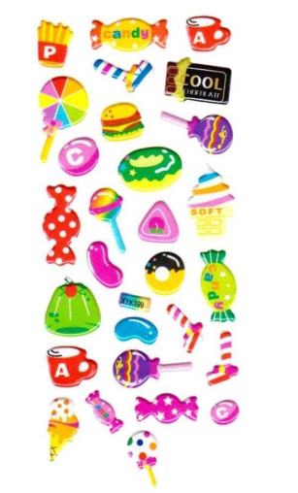
EXTENSION
½ of 22 = _________
½ of 24 = _________
½ of 26 = _________
½ of 28 = _________
½ of 30 = _________

½ of 14 = ____________

½ of 16 = ____________

½ of 18 = ____________

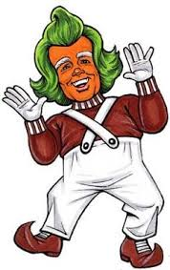
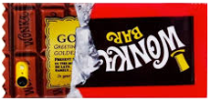
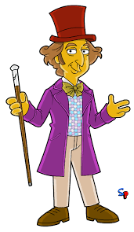
½ of 20 = ____________

