Elmwood Class Home Learning Activities for Week Beginning 22nd June 2020
 | Monday | Tuesday | Wednesday | Thursday | Friday
English  Focus Text for the week:  Under the Sea by Anna Milbourne | Letter of the Day: S  https://www.youtube.com/watch?v=1orYZAoGgoQ  Shared Reading:  Read the book to find out what the biggest creature is that lives in the sea.  Independent Writing:  Encourage your child to select an illustration to write about.  Or  Write about one of the sea creatures seen in the book. | Letter of the Day: A  https://www.youtube.com/watch?v=hBAuIzZttP4  Shared Reading:  Read the book to find out how dolphins breathe.  Independent Writing:  Encourage your child to select their favourite animal to write about.  Or  Write a list of animals that live in the sea. | Letter of the Day: T  https://www.youtube.com/watch?v=M5gUg06rock  Shared Reading:  Read the book to find out about things that live at the bottom of the sea.  Independent Writing:  Encourage your child to select a picture of a weather condition to write about.  Or Select a sea animal to write about. | Letter of the Day: P  https://www.youtube.com/watch?v=HMMy6Y-nduE  Shared Reading:  Read the book and use some descriptive words to describe the ocean habitat.  Independent writing:  Label an interesting page from the book with names of objects and animals. | Letter of the Day: I  https://www.youtube.com/watch?v=tGxaEdXOSk8  Shared Reading:  Read the book then select favourite sea animal to talk about.  Independent writing:  Encourage your child to write about an activity they enjoyed over the past week. You might like to use photographs or objects as stimulus for writing.
Maths  Focus for the week:  Fractions | Introducing Fractions  Watch the fraction story PowerPoint.  Colour in the shapes to show halves - ½ & quarters - ¼.  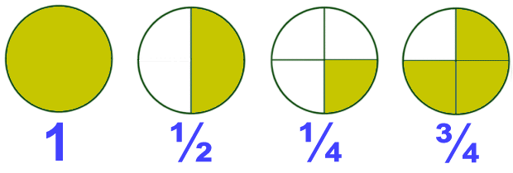 | Food fractions  Whole, ½ and ¼  Look at the different food images and talk about which are whole, halves - ½ & quarters ¼.  Attach workbook | Fractions of Shapes and Quantities  Can you find half of the shapes and quantities?  Work through the attached worksheets. | Fractions Outdoors  Have go at using natural materials to demonstrate fractions outside.  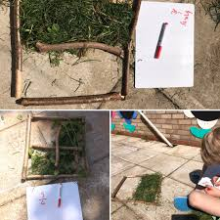  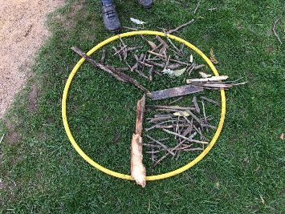 | Fraction Art  Have some fun using fractions of shapes to create pictures.  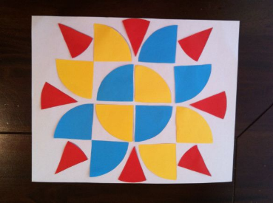  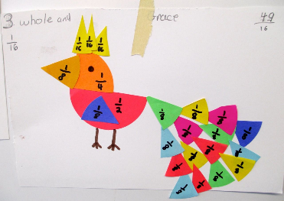
Wider Curriculum | Art  Impressionism  Please look at the painting  “Dusk in Venice” by Monet.  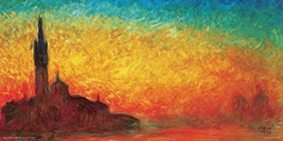  Talk about what you can see in the picture, the colours used and encourage your child to express an opinion (e.g. like/don’t like).  Encourage your child to create their own interpretation of the painting using their choice of art material available at home. | Science  Motion in the Ocean  We will explore and identify different aspects of an underwater habitat.  Create an underwater tableau in a tray using sand/water/seaweed/ shells/pebbles/coral  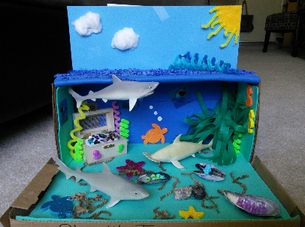Listen to sounds of dolphins/whales  Taste salt water/fresh water  Identify common features of animals that live in the sea (ie; fish- eyes, fins, gills, scales/ tentacles  Compare sizes of sea creatures ie; blue whale, plankton (could be done outside with rope/measuring tools)  Classify which live in salt/fresh water | PSHE:  Activities to Promote Positive Mental Health and Well-Being  Take a Mindful Walk  Go for a stroll and designate 5 minutes of your walk to discuss what your child sees, feels, hears, and smells.  Designate short periods of time to zone into your senses.  LOOK at the trees, dandelions, butterflies. Try to find bugs, ants, and other creepy crawly’s.  LISTEN for birds, woodpeckers, and lawnmowers.  FEEL the weather and the sensations in your body.  SMELL the flowers, spring scents, or even rain.  Pro Tip: Spend one minute in complete silence just noticing and feeling what’s around you both.  Have a go at The Rainbow Meditation  https://raisingselfawareness.com/rainbow-meditation/  Breathing Buddies  Ask your child to lie down and put his/her favourite soft toy on their belly.  Ask them to inhale deeply for a count of three. Then ask them to exhale for a count of 4.  Watch the teddy rise and fall as they breathe in and out. Do 5 to 10 rounds. | DT / Food Tech  Topic:  To make foods connected to the sea, rivers or water. You might like to try one of the following:  - Crispy seaweed  https://cookpad.com/uk/recipes/332745-chinese-style-crispy-seaweed  - Tuna mayo sandwich  - Sesame prawn toast  https://www.bbcgoodfood.com/recipes/sesame-prawn-toast  - Fish cakes  https://www.bbc.co.uk/food/recipes/easy_kids_fishcakes_70996  - Fish fingers  https://www.kidspot.com.au/kitchen/recipes/healthy-fish-fingers-recipe/x0oepe2r?r=collection/seafoodrecipes&c=iua0ofqr/Seafood%20recipes  - Tuna and Spinach Pancakes  https://www.bbcgoodfood.com/recipes/spinach-tuna-pancakes  - Tuna Pasta Bake  https://www.bbcgoodfood.com/recipes/tuna-sundried-tomato-pasta-bake | Music  Listening: Encourage your child to listen to a variety of music with a water theme and encourage them to describe what they hear in simple terms.  - Water Music by Handel  - The Sea by Debussy  - The Moldau by Smetana  - Spring Waters by Rachaninoff  - The River by Schubert  - Still Waters by Tony Banks  - Yellow River by Xinghai  Interacting/Performing:  Make your own musical instruments using water.  http://kiddley.com/2013/07/09/10-great-musical-instruments-to-make-at-home/  Use musical instruments available at home / instruments you have made or household objects to create water-like sound effects.
Health and Fitness | A selection of Yoga stories to work through: https://www.youtube.com/user/CosmicKidsYoga  A Tai Chi sequence for children you might like to try with your child: https://www.youtube.com/watch?v=YMVg5diOiMs&t=428s  PE with Joe Wicks: https://www.youtube.com/watch?v=zKhGfdSvG3s  Daily walk following current social distancing guidelines...

