Home Learning Activities for Week Beginning 13th July 2020
 | Monday | Tuesday | Wednesday | Thursday | Friday
English  Focus Text for the week:  Lost and Found | Letter of the Day: H  https://www.youtube.com/watch?v=C8EtaVKk8Fg  Shared Reading:  Read the book to Discover who / what the visitor was?  Independent Writing:  Encourage your child to select an interesting page from the book to write about.  Research:  Find out what it's like at the South Pole and what animals live here. The South Pole https://youtu.be/t3StWheKtq8 | Letter of the Day: B  https://www.youtube.com/watch?v=W5D3ySh7s2c  Shared Reading:  Read the book to find out who the little boy asked to find out where the visitor came from. (there are 3 in total)  Independent Writing:  Encourage your child to select an interesting page from the book to write about.  Or  Choose a picture of the South Pole to write about. | Letter of the Day: F  https://www.youtube.com/watch?v=oT5Rzwj1xdw  Shared Reading:  Read the book to find out what the characters put in their suitcase.  Independent Writing:  Encourage your child to select an illustration to write about.  Or  Write a list of items you would put in your suitcase if you were going to the South Pole. | Letter of the Day: L  https://www.youtube.com/watch?v=T4YvWb0WMRQ  Shared Reading:  While reading the book, find and note down a selection words that describe feelings.  Independent writing:  Label an interesting page from the book using words or by pointing to icons in your PODD.  Or  Look for a stimulating picture of penguins to write about. | Letter of the Day: J  https://www.youtube.com/watch?v=TeYynmQ0v3Q  Shared Reading:  Read the book then talk about what it might be like to (visit the South Pole) (be lost) (be lonely)  Independent writing:  Encourage your child to write about an activity they enjoyed over the past week. You might like to use photographs or objects as stimulus for writing.
Maths  Comparing and Measuring Length | Comparing and Measuring Length Outdoors  Collect natural objects of various lengths and order them from shortest to longest or measure their length using a ruler.  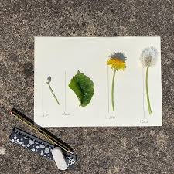  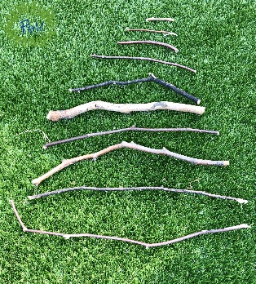  Extension: Find an item longer than/shorter than a given length e.g. 10cm. Use ruler to help. | Non-standard units of measurement:  Look through the powerpoint ‘Length Introduction’, then have a go at measuring the legnth of some household objects using non-standard units of measurement e.g. paperclips, lego blocks, hand spans as shown in the powerpoint.  Have a go at measuring the length of the crocodiles in the worksheet available using your child’s choice of non-standard unit.  Alternatively, order them from shortest to longest or find one longer than/shorter than another.  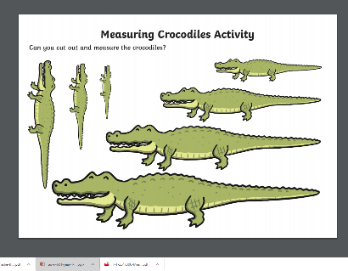 | Estimating length with Lego  .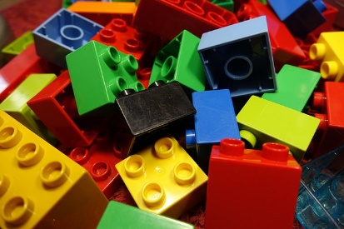Lego is a great way to introduce pupils to the world of measurements.  Materials you’ll need:  - Lego blocks  - Markers  - A sheet of paper  - Items to measure  To begin, create three columns labelled:  Item,  Prediction,  and Result.  Write down the item name in the appropriate column. You could draw a picture of the item for children or show them a symbol. Go through each item and ask for a prediction before performing the measurement. When it finally comes time to measure, stack the lego blocks until you reach the height of the object. Write the result, and you’re done!  To extend this activity:  Use a ruler or tape measure to record the height / length of the lego or the objects. How many cm’s are they? | Estimating & Measuring circumference  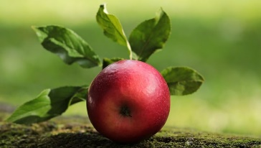  In this activity, apples will be used to practice pupil’s math skills of estimation and measurement. You will need:  - An apple  - A ruler  - Scissors  - Yarn or string  Place the apple in front of your child. Let them hold the apple to ascertain its circumference. Encourage pupils to cut the yarn to a length that would wrap around the apple. This will require estimation. Use a ruler to see how many cm’s the apples circumference is.  To extend this activity:  Use other round objects of varying sizes and estimate the amount of string needed for each measurement.  When you've done various objects line up the strings in order from shortest to longest.  Can you use a ruler to tell / read the circumferences? | Measuring in centimetres  Practice measuring the length of objects (real or using the worksheet provided) using a ruler.  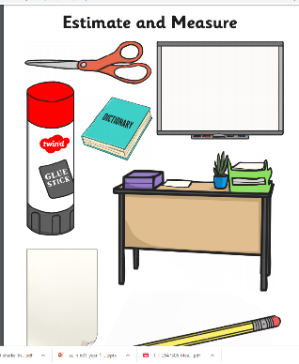  Measurement Activities and online games. Select the level that best suits your child.  https://www.splashlearn.com/measurement-games
Wider Curriculum | Art  Impressionism  Please look at the painting ‘Irises’ by Vincent Van Gogh.  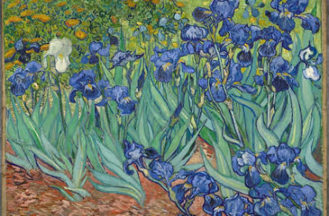Talk about what you can see in the picture, the colours used and encourage your child to express an opinion (e.g. like/don’t like).  Encourage your child to create their own interpretation of the painting using their choice of art material available at home. | Science  Cooling and Freezing  • Experience differently shaped and scented ice cubes e.g. blue food colouring with peppermint essence, rose water and pink colouring, clear with almond essence.  • Make ice cubes in bags, balloons and trays.  • Use all available senses to explore ice cream. Make sorbet e.g. by simply freezing grape juice.  • Explore making jelly by cooling in a fridge.  • Make and explore coloured ice cubes on paper. Watch them melt. Use glitter and paint or food colouring to identify the trail made as they melted. Contrast frozen jelly cubes with non-frozen.  • Freeze a selection of common foods and objects e.g. water, chocolate, coins, wood, plastic box. Note the effects. Do they change or stay the same? Predict if they will return to their original form on melting? Make a chart to represent the predictions and the results.  • Explore the effects of freezing on different materials. Predict how materials may react. Note any changes e.g. the water pushed the lid off the Tupperware box, the egg white has changed. Look at the materials every two minutes to see how quickly they thaw and what happens to them as a result. Record which objects thaw the quickest and suggest how the process can be speeded up. | PSHE:  Activities to Promote Positive Mental Health and Well-Being  Gratitude Scavenger Hunt  https://www.worthybeyondpurpose.com/latest-news/2018/11/29/5-mindful-activities-for-you-and-your-kids-this-winter  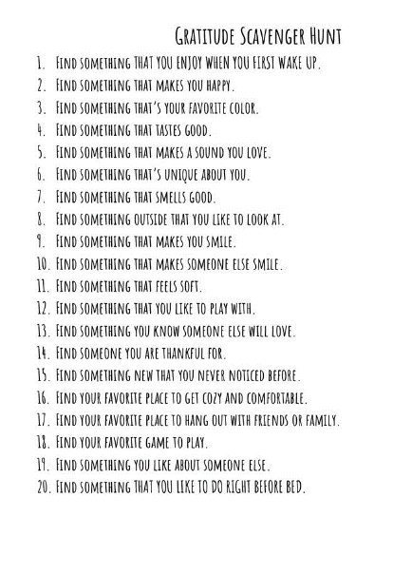 | DT / Food Tech  Topic:  To make foods / drinks connected to the sea, rivers or water.  Today, you might like to focus on the water aspect and experiment with different variations of lemonade.  You will find 10 different lemonade recipes using the link below:  https://www.bbcgoodfood.com/recipes/collection/lemonade  For example the one in the photo below uses lemon, raspberries, ginger and rosemary.  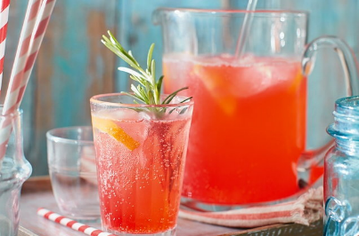  I will love for you to share some ideas or even photos of your end product! | Music  Listening: Encourage your child to listen to a variety of music with a water theme and encourage them to describe what they hear in simple terms.  - Water Music by Handel  - The Sea by Debussy  - The Moldau by Smetana  - Spring Waters by Rachmaninoff  - The River by Schubert  - Still Waters by Tony Banks  - Yellow River by Xinghai  Interacting/Performing:  Make your own musical instruments using water.  http://kiddley.com/2013/07/09/10-great-musical-instruments-to-make-at-home/  Use musical instruments available at home / instruments you have made or household objects to create water-like sound effects.
Health and Fitness | A selection of Yoga stories to work through: https://www.youtube.com/user/CosmicKidsYoga  A Tai Chi sequence for children you might like to try with your child: https://www.youtube.com/watch?v=YMVg5diOiMs&t=428s  PE with Joe Wicks: https://www.youtube.com/watch?v=zKhGfdSvG3s  Daily walk.

