Home Learning Week beginning 29/6/20
These are activities for the week you can pick and choose and do what you like when you like!
Literacy :
Working with words, letters and sounds
Our letters this week are:

G https://www.youtube.com/watch?v=0KXtxIiQ7gk&t=13s
H https://www.youtube.com/watch?v=NtUSMBzacQ0
I https://www.youtube.com/watch?v=P56hZEhqFCw
J https://www.youtube.com/watch?v=6KXX6fCKWes&t=45s
K https://www.youtube.com/watch?v=OGVbUgqp7LQ&t=11s
L https://www.youtube.com/watch?v=qEXMoeYe47c&t=4s

Don’t forget to practise writing the letter and finding words beginning with the letter in PODD books/PODD devices/Eye gaze, or objects around the house.
Independent writing
You can use any photographs, pictures or objects that your child might find interesting as a stimulus for independent writing.
Use the alphabet page in their PODD books/PODD devices/Eye gaze or keyboard page to choose letters and create words or sentences about their chosen topic. Make sure that they choose letters to write their name on their work.

Book
We’re reading “ Welcome .” this week Katie has done a video on the school website you can access it here:
https://woodlandssurrey.primarysite.media/playlist/books

Or it is on youtube https://www.youtube.com/watch?v=pPA1Y05xct8

Who did the polar bear meet?

Finish the sentence We need to find a new …

Make an Alphabet Books About Things I Really, Really Like!

This week make a book about your favourite thing to do outside !
You can use paper and pen (and stick on photos or Google Images), book making apps such as Pictello or Book Creator, or online book making sites such as tarheelreader.org. You can also use cheap photo albums and put a small piece of paper on the photo that has the sentence.
1) Create a page for each of their favourites. You do not have to do the whole alphabet; just put the pages in alphabetical order. It is ok if the book only has four pages! The most important thing is that your child is learning that letter of the alphabet is important because it is used to write the name of this thing I love!
2) Read the books often. Reading can look like just looking at the photos and talking about the pictures, not reading the words on all the pages, or just flicking through to find your special favourite page!
3) When you read the books, use your child’s communication system to comment on the pages, talk about the pictures, or simply say ‘let’s turn the page for MORE’.
4) Talk about special letters during the day.

Art activities:

Stick or spoon puppets.

To make a set of superhero puppets you will need:

- Superhero mask and badge printable
- Craft sticks
- Flesh coloured card
- Coloured paper/ card
- Pens
- Glue
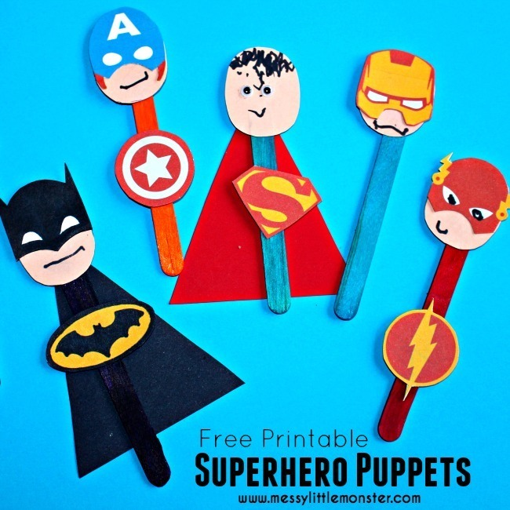
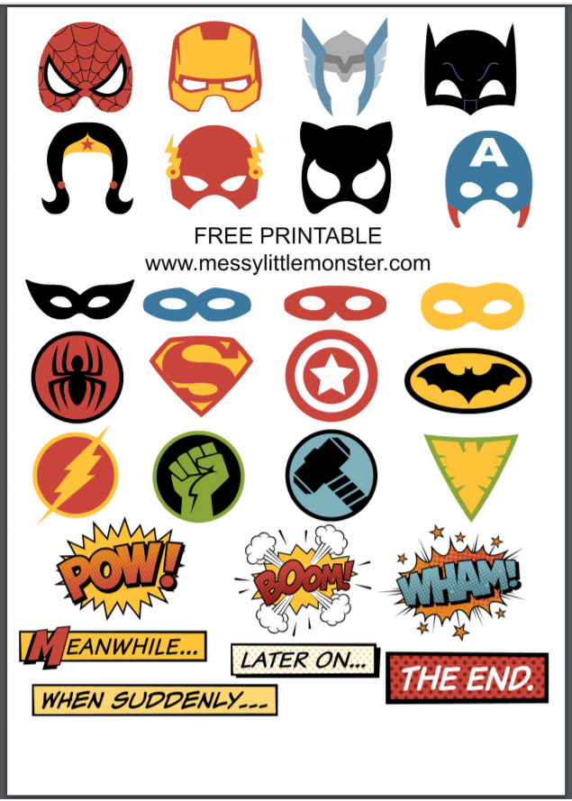
Print out the Batman, Superman, Ironman, Flash and Captain America masks and badges. Glue to craft sticks to make your own mini superheroes. They are perfect for imaginative play and story telling

Or print out some animal pictures, or cut up some photos and attach to wooden spoons or lollipop sticks and tell a story!
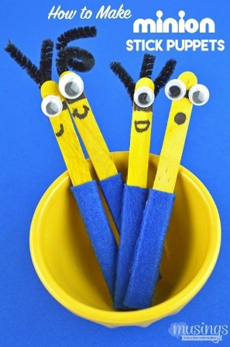
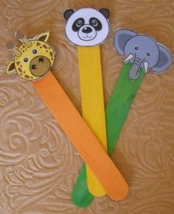

Science Activities
- Listen to different animal sounds on CD and video.
Make model animal bodies with dough, showing main body parts.
https://www.youtube.com/watch?v=uF74DU34q2Y

RE Activities
- Watch the powerpoint ‘Mosques of the world’ and listen to the call to prayer (attached)
- Look at the powerpoint ‘Introduction to mosques’ (attached)
- Prayer mat:
- Read ‘Background – prayer mat’ (attached)
- Either colour or collage one of the Muslim prayer mats from ‘prayer mat colouring’ (attached)
- Make a compass – watch the Youtube link - https://www.youtube.com/watch?v=QiSp6pGe0w0
Muslims pray 5 times a day facing Mecca which from the UK is East

PE Activities:
Warm up song https://www.youtube.com/watch?v=MugzDjGDYjo&t=16s

Water play
Splash, Squirt, Pour, and Drink!
Car Wash!
- Big plastic tub (or bathtub)
- Cars/trucks (that can go in water)
- Squeezers and squirters
- Cups & jugs & measuring cups for pouring
- Water!!

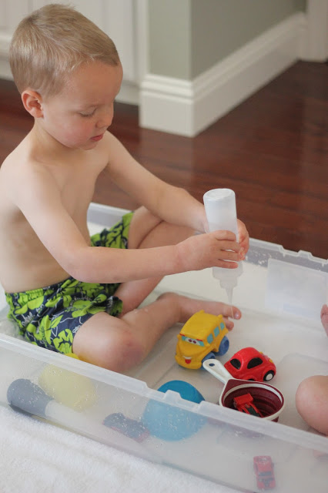

Pouring Station (Bonus maths activity – introducing capacity!)
Grab various containers from around the house to pour and dump from.
Try making some of the water coloured – this is optional. Yes, it’ll turn to brown by the end but it’s fun in the beginning.
- storage tub or large tray
- containers
- water
- food colouring
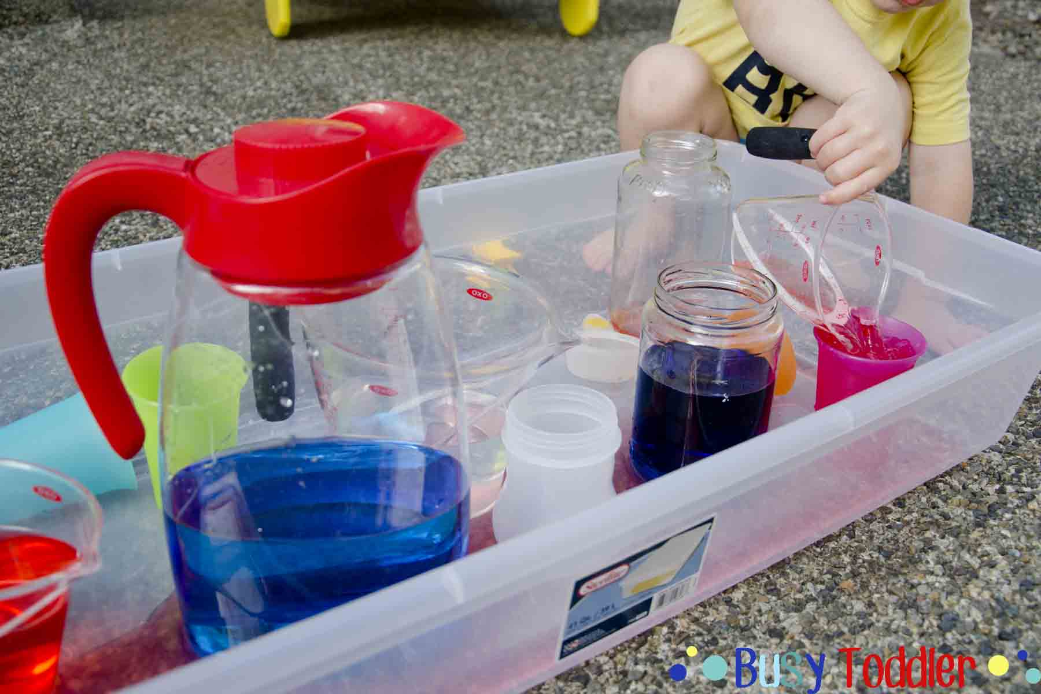
Scoop and Find
Add some ping pong balls or other balls that will float into the water table and ask your child to scoop them out into another bucket. If it’s an extra hot day, add ICE and ask them to scoop that instead.

Take care. Have fun!

