Home Learning Week beginning 6/7/20
These are activities for the week you can pick and choose and do what you like when you like!
Literacy :
Working with words, letters and sounds
Our letters this week are:

M https://www.youtube.com/watch?v=Nvn9QvV7Aqk
N https://www.youtube.com/watch?v=qE5HEeoVGb0&t=8s
O https://www.youtube.com/watch?v=oWbY5EKys60&t=12s
P https://www.youtube.com/watch?v=-v1fg2Hp63s&t=4s
Q https://www.youtube.com/watch?v=NKAookrRV4s&t=4s
Don’t forget to practise writing the letter and finding words beginning with the letter in PODD books/PODD devices/Eye gaze, or objects around the house.
Independent writing
You can use any photographs, pictures or objects that your child might find interesting as a stimulus for independent writing.
Use the alphabet page in their PODD books/PODD devices/Eye gaze or keyboard page to choose letters and create words or sentences about their chosen topic. Make sure that they choose letters to write their name on their work.

Book
We’re reading “Cock a moo moo,” this week Katie has done a video on the school website you can access it here:
https://woodlandssurrey.primarysite.media/playlist/books

Or it is on youtube
https://www.youtube.com/watch?v=2AOpnLO3NME

Make an Alphabet Books About Things I Really, Really Like!

This week make a book about your favourite cartoon characters !
You can use paper and pen (and stick on photos or Google Images), book making apps such as Pictello or Book Creator, or online book making sites such as tarheelreader.org. You can also use cheap photo albums and put a small piece of paper on the photo that has the sentence.
1) Create a page for each of their favourites. You do not have to do the whole alphabet; just put the pages in alphabetical order. It is ok if the book only has four pages! The most important thing is that your child is learning that letter of the alphabet is important because it is used to write the name of this thing I love!
2) Read the books often. Reading can look like just looking at the photos and talking about the pictures, not reading the words on all the pages, or just flicking through to find your special favourite page!
3) When you read the books, use your child’s communication system to comment on the pages, talk about the pictures, or simply say ‘let’s turn the page for MORE’.
4) Talk about special letters during the day.

Art activities:
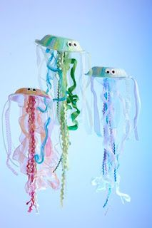
Jelly fish puppets
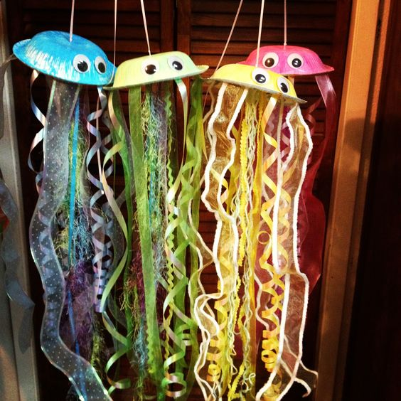

Colour an upside down paper bowl and glue matching ribbons to their bellies; then add googly eyes make them come alive.

Science Activities

- Compare and contrast the different animals.
- Make simple recordings regarding comparisons.
Have a look at the attached power points together and talk about farm animals

History Activities - Looking at homes in the past
This week we are looking at how kitchens have changed
Go back in time with Magic Grandad !
https://www.youtube.com/watch?v=bpwFnNTXt2c

Bake some bread or make some small cakes, feel textures, smell etc

PE Activities:
Warm up song https://www.youtube.com/watch?v=MugzDjGDYjo&t=16s

Sing active songs
Sing one of these classic songs, and add some actions!
- I’m a Little Teapot
- If You’re Happy and You Know It
- The Hokey Pokey
- Ring around the Rosie
- Head, Shoulders, Knees, and Toes
- Teddy Bear, Teddy Bear, Turn Around
- Here We Go ‘Round the Mulberry Bush

Be the weather
Children can use their bodies to be different kinds of weather, such as:
- rain
- snow
- earthquake
- tornado
- wind

Copy me!
This is where you can get in your workout for the day. Simply do a series of exercises or silly actions, and have your children copy you. Jump like a kangaroo. Scratch like a monkey. Run in a place. (Whatever it takes to get that heart rate up!)

Maths activities
Please select one of the activities from both the ‘Functional Maths skills at home’ and ‘Ideas for Maths Outdoors’ sheets from your home learning pack
Muffin Pan Fun:
This is a fun activity that you can do with supplies you probably already have around the house. Give your child several plastic balls and an empty muffin pan. Help your child put each ball in a compartment, they may want to dump them all out, gather them up, and repeat the activity. You can turn this into a good learning activity by counting the balls as you put them in, and even counting the full and empty compartments. If you have coloured plastic balls, you can name the colours or sort balls by colour.
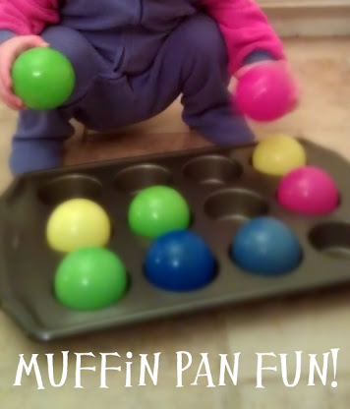

Take care. Have fun!

