Squirrels Class-Week beginning 13th July 2020
Suggestions of some home learning activities. Please feel free to adjust to suit your child.
Area of learning:
Literacy  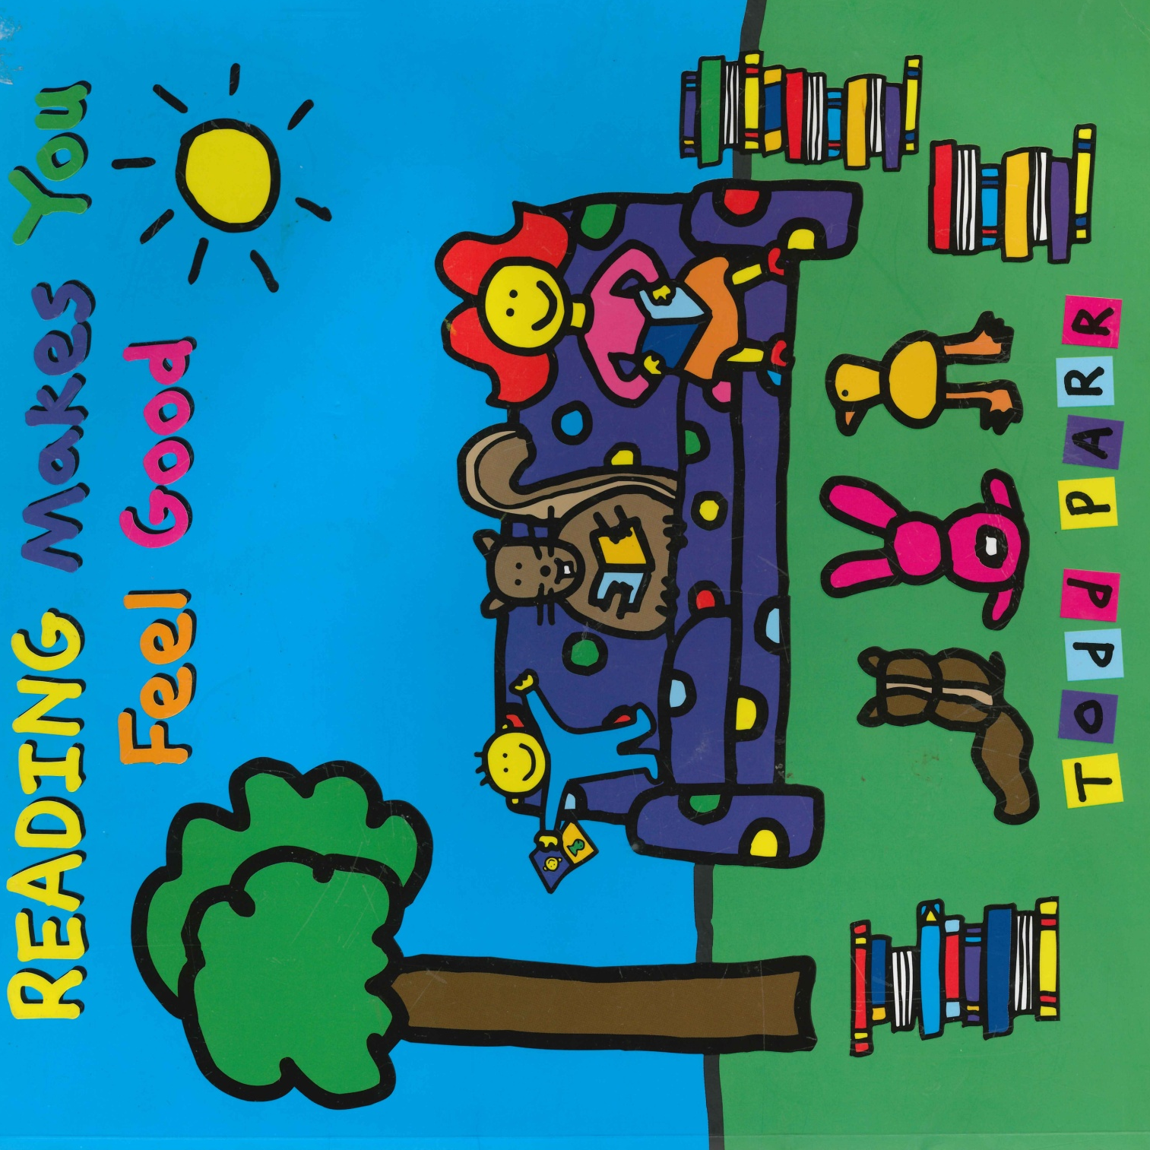 | Book: Reading makes you feel good by Todd Parr  See Powerpoint book on the website  Shared reading: Follow the CAR (Comment and wait; Ask for participation and wait; Respond by adding a little more) and CROWD (Completion, Recall, Open-ended, Wh-, Distancing).  Shared writing:  Step 1:  Write a sentence about the book using the sentence starter: 'Reading makes me feel …' Take turns to write sentences. Write your name at the end of your sentence. Try to think about the letters in the word you want to spell.  Step 2:  Read through your sentences. 'Reading makes me feel…' Look for your names at the end of your sentence. Try to think about the letters in your name.  Step 3:  Ask your child to cut up their sentences between each word. Or scan the sentence with a pair of scissors and look for any attempt your child makes to communicate they want to make a cut in the paper.  Step 4:  Ask your child to stick the words down in a sentence and see what order they stick them in. Model how you would read the sentence.  Step 5:  Cut up the sentences you wrote and see if you can order them. Stick them in your book. Talk about how the sentences should sound.  Independent writing: Use your alternative pencil to write about something you are interested in and your name. Adults to present whole alphabet and go through letters one at a time, using a flipchart, PODD book or alphabet letters. Any attempt to select any letter of the alphabet is praised and encouraged and recorded by the adult/partner.  Independent reading: Choose a book of your choice and look at the pictures, Comment on the pictures and words. Turn the pages one at a time. Oxford Owl or Reading Eggs have some free e-books. Lilac band of Oxford Reading Tree are the ones we use the most.  Letters of the day: J, K, L, M and N. Focus on one letter a day. Use the Bounce Patrol videos to reinforce the letter.  Letter work: See the symbols labelled each letter of the day on the website-sort the symbols by letter. Look for all the symbols for one letter each day.
Maths  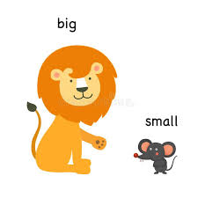 | - Boardmaker Online activities and Number songs  - Use the numicon and number line to count objects around the house/garden  - Functional maths skills at home  - Ideas for Maths Outdoors  - Try some free number games on abcya.com-https://www.abcya.com/grades/prek/numbers  - Read the big and small story on website  - Use the Powerpoint to talk about big and small objects  - Play a big and small hide and seek game-open your eyes is it a big or small object?  - Sort big and small objects between two hoops.
Science | Topic: Habitats  Intent: Pupils can begin to classify and identify features of animals that live on land or in the sea  - Classify pictures of plants life into sea and land  - Talk about 4 different habitats-Arctic, Desert, Grassland, Ocean. Talk about animals you might find in these habitats. Could you find a toy of this animal? Can you sort pictures of animals onto different coloured paper?
Geography  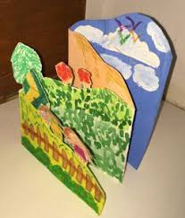 | Topic: Place knowledge- Town and Countryside  - Make a countryside landscape picture using 3D materials- grass, shiny paper/sun, tissue paper/sky
PE   | Topic: Athletics  - Mini Olympics-Try several different Olympic style athletic activities and have a competition amongst your household.  - Javelin, Discus, Long Jump, Short Jump, Running, Hurdles, Relay races etc.  - Stop and showcase any achievements
Art  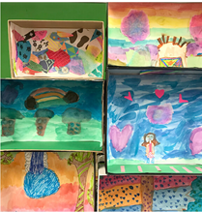 | Topic: Imaginary Places  Continue to create a tiny imaginary place in a small box  - Make some creatures and objects for your box  https://artfulparent.com/create-these-awesome-mini-worlds-with-shoebox-dioramas-for-kids/
Music | Topic: Composition  - Watch kids Zumba. Copy all the moves. Move to the beat with your head or hands.  - Listen to your music for each poem. Can you develop it? Can you add anything?  - Develop a piece of music using the website. Composing website-https://www.classicsforkids.com/games/compose_your_own_music.php  - Record the music and play to friend.

Suggested Timetable
Monday | Tuesday | Wednesday | Thursday | Friday
Literacy | Literacy | Literacy | Literacy | Literacy
Maths | Maths | Maths | Maths | Maths
Geography | Art | PE | Science | Music

