Home Learning Activities for Week Beginning 15th June 2020
 | Monday | Tuesday | Wednesday | Thursday | Friday
English  Focus Text for the week:  The River | Letter of the Day: J  https://www.youtube.com/watch?v=TeYynmQ0v3Q  Shared Reading:  Read the book to find out where the little fish belongs.  Independent Writing:  Encourage your child to select an illustration to write about. | Letter of the Day: V  https://www.youtube.com/watch?v=A1BeBFqwyFc  Shared Reading:  Read the book to find out where different animals live.  Independent Writing:  Encourage your child to select their favourite animal to write about.  Or  Label one of the habitats illustrated in the book with names of plants and animals. | Letter of the Day: W  https://www.youtube.com/watch?v=4yCg2dZaaD0  Shared Reading:  Read the book and discuss what plants you may see by a river.  Independent Writing:  Encourage your child to select a picture of a weather condition to write about.  Or  Write a list of habitats the little fish encounters on her journey. | Letter of the Day: X  https://www.youtube.com/watch?v=qj4nyH2aWVc  Shared Reading:  Read the book and discover what the beavers are building and research what its purposes are.  This Video will help you .  https://youtu.be/VuMRDZbrdXc  Independent writing:  Find an interesting image/video about beavers to write about.  Or Create a fact sheet about beavers. | Letter of the Day: Z  https://www.youtube.com/watch?v=wLu-bccANRg  Shared Reading:  Read the book what animals can be seen at night.  Independent writing:  Encourage your child to write about an activity they enjoyed over the past week. You might like to use photographs or objects as stimulus for writing.
Maths  Focus for the week:  3D shapes | Introduction  3D shape Rap:  https://www.youtube.com/watch?v=2cg-Uc556-Q  3D shape PowerPoint:  Look at the shapes in the PowerPoint, can you name them? Can you recognise any shapes within shapes for example cylinder has 2 circles etc. | Stack roll or slide.  https://youtu.be/kj-2c208cCc  Find 3D shapes in your home. Identify the shapes and then conduct a simple experiment to see which can stack, which can roll and which will slide.  Complete one of the 3D shape sorting activities. (worksheet attached) | Properties of 3D shapes  https://youtu.be/3nLpD6bE4fE  Look at the PowerPoint 3D shapes. Talk about each the shapes. Name and describe each shape. How many sides etc, you can also talk about the 2D shapes within shapes.  If appropriate, please complete the 3D shape properties worksheets. Alternatively, colour in a variety of 3D shapes. | 3D shapes in the environment  3D shapes are all around us, they are in our homes we build with them we pack foods and objects in them. Look at the PowerPoint “3D shapes in the environment” talk about the objects and the shapes you can see.  Shape Safari  Can you find any 3D shapes in your home or outside? Can you find these shapes in your PODD or using the pics in PowerPoint. | Scrap Models or Contruction  Use scrap materials such as boxes, containers etc to make 3 Dimensional models.  Make a rocket, robot, or a cityscape out of 3D materials?  or  Construct using any 3D shapes you can find in your home. Can you build a city or a house?
Wider Curriculum | Art  Topic: Impressionism  Please look through the PowerPoint about Claude Monet, then look at the painting “Waterloo Bridge at Dusk” and help your child to create their interpretation of the painting.  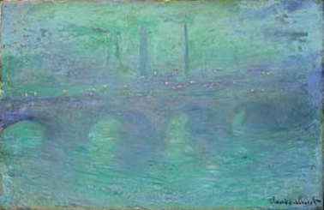 | Science  Topic: Motion in the Ocean  Explore and observe the concept of waves:  https://www.youtube.com/watch?v=WHPEKLQID4U  - Create “waves” in trays of water  - Listen to sound of surf/waves  - Water sprays and fans to recreate nautical atmosphere  Making waves: Try this......  https://youtu.be/Pcu286G46Ao  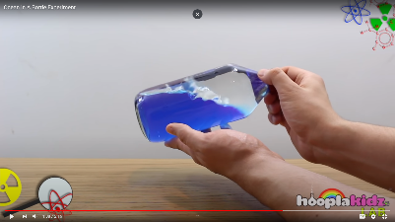More Experiment ideas:  1.Fill a pan/water tray halfway with water.  2.Have children take turns blowing across the surface of the water.  3. Predict what happens if they blow gently? What happens if they blow very hard?  4. Put a drop of food colouring into the water at one end of the pan. Have children blow from that end of the pan. What happens to the coloured ‘current’? | PSHE:  Activities to Promote Positive Mental Health and Well-Being  The Listening Game – mindfulness activity  https://www.youtube.com/watch?v=uUIGKhG_Vq8  Be the Pond – Meditation for Children  https://www.youtube.com/watch?v=wf5K3pP2IUQ  Mindfulness Activity Cards (attached):  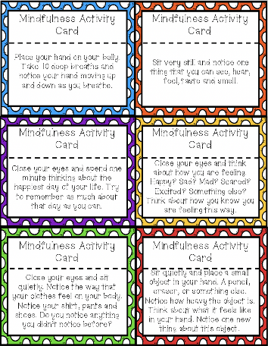  Make a Mind Jar:  https://www.cosmickids.com/mindfulness-activities-kids/ | DT / Food Tech  Topic:  To make foods connected to the sea, rivers or water. You might like to try one of the following:  - Crispy seaweed  https://cookpad.com/uk/recipes/332745-chinese-style-crispy-seaweed  - Tuna mayo sandwich  - Sesame prawn toast  https://www.bbcgoodfood.com/recipes/sesame-prawn-toast  - Fish cakes  https://www.bbc.co.uk/food/recipes/easy_kids_fishcakes_70996  - Fish fingers  https://www.kidspot.com.au/kitchen/recipes/healthy-fish-fingers-recipe/x0oepe2r?r=collection/seafoodrecipes&c=iua0ofqr/Seafood%20recipes  - Tuna and Spinach Pancakes  https://www.bbcgoodfood.com/recipes/spinach-tuna-pancakes  - Tuna Pasta Bake  https://www.bbcgoodfood.com/recipes/tuna-sundried-tomato-pasta-bake | Music  Listening: Encourage your child to listen to a variety of music with a water theme and encourage them to describe what they hear in simple terms.  - Water Music by Handel  - The Sea by Debussy  - The Moldau by Smetana  - Spring Waters by Rachaninoff  - The River by Schubert  - Still Waters by Tony Banks  - Yellow River by Xinghai  Interacting/Performing:  Make your own musical instruments using water.  http://kiddley.com/2013/07/09/10-great-musical-instruments-to-make-at-home/  Use musical instruments available at home / instruments you have made or household objects to create water-like sound effects.
Health and Fitness | A selection of Yoga stories to work through: https://www.youtube.com/user/CosmicKidsYoga  A Tai Chi sequence for children you might like to try with your child: https://www.youtube.com/watch?v=YMVg5diOiMs&t=428s  PE with Joe Wicks: https://www.youtube.com/watch?v=zKhGfdSvG3s  Daily walk following current social distancing guidelines...

