Home Learning Activities for Week Beginning 6th July 2020
 | Monday | Tuesday | Wednesday | Thursday | Friday
English  Focus Text for the week:  Lila and the Secret of Rain  You-tube Video Book  https://youtu.be/EDsHU0CmtBs | Letter of the Day: C  https://www.youtube.com/watch?v=ieo0LPYdUfQ  Shared Reading:  Read the book to find out who Lila is.  Independent Writing:  Encourage your child to select an illustration to write about.  Or  Write about your favourite part of the book. | Letter of the Day: K  https://www.youtube.com/watch?v=j_LNrXd7Jx8  Shared Reading:  Read the book to find out what a dry spell is.  Independent Writing:  Encourage your child to select an interesting page from the book to write about.  Or  Write a list of objects you might see in a Kenyan village. Use the illustration to help you. | Letter of the Day: E  https://www.youtube.com/watch?v=Cm4OnFLl5Uw  Shared Reading:  Read the book to find out what Lila must do to make it rain.  Independent Writing:  Write a set of instructions for Lila of what she needs to do to make the rain fall again. | Letter of the Day: U  https://www.youtube.com/watch?v=yWiRgOuaS84  Shared Reading:  Read the book to find out what the villagers did when the rain came.  Independent writing:  Write a sad story that Lila could tell the sky.  Or  Complete the Expanded Noun sentences. This is where you add adjectives to make the sentence or phrase more interesting, | Letter of the Day: R  https://www.youtube.com/watch?v=-9BzWBufH1s  Shared Reading:  Read the book then talk about what it might be like to experience such extreme weather conditions.  Independent writing:  Encourage your child to write about an activity they enjoyed over the past week. You might like to use photographs or objects as stimulus for writing.
Maths  Comparing and Measuring Weight | Introduction to Heavy and Light (Sesame Street):  https://www.youtube.com/watch?v=QCPYaTx2v0w&t=4s  Heavy and Light interactive balance scales game  https://www.splashlearn.com/measurement-games  Please select and work through the ‘Weight’ activity.  Look for a selection of heavy and light objects around your home / garden.  You might like to record what you have found using the recording sheet available to print. | Balance it out  Make yourself a simple weighing device like the one below...  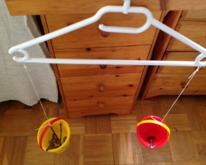Place a favourite toy in 1 scale and use Lego blocks in the other until you reach balance. How many Lego blocks did you need? Try lots of different things that you have around the home.  Alternatively, compare the weight of household objects or natural object found outside. What is the lightest object you can find outdoors?  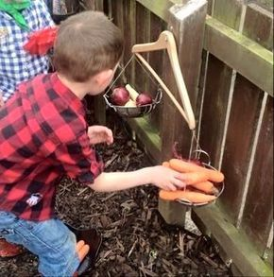 | Predicting heavier, lighter than or the same of objects  Today you will be making predictions and then checking if your prediction was correct.  Use a selection of objects that you can find around the house.  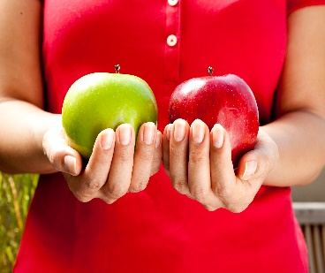  Sort objects into pairs and make some pairs very easy to identify / predict if it is heavier or lighter than its paired object. Also make some the same. You can also use the scales you made yesterday to weigh some of the objects again using a common method of weight – apple = 10 lego blocks etc. | Weighing Ingredients  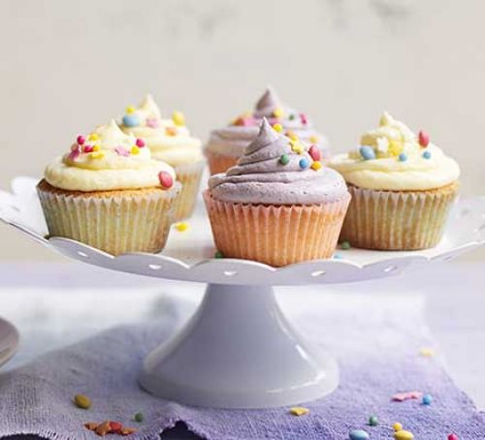  Choose 1 of these recipes or choose 1 that you are familiar with, it's time to put some of those weighing and measuring skills to a really functional use.  Using a kitchen scale, practice measuring out the weight of ingredients for a recipe.  BAKING  https://www.bbcgoodfood.com/recipes/collection/kids-baking | Developing Functional Maths Skills  Practice using a kitchen scale to measure the weight of a variety of objects. You might like to use the worksheet available to print for ideas and to record your findings.  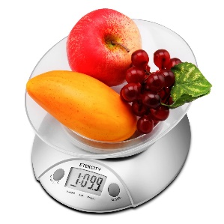  Alternatively, select 2 activities from your Maths Outdoors sheet.
Wider Curriculum | Art  Impressionism  Please look at the painting ‘Almond Blossoms’ by Vincent Van Gogh.  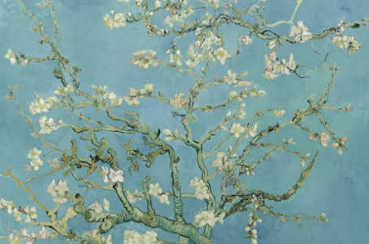Talk about what you can see in the picture, the colours used and encourage your child to express an opinion (e.g. like/don’t like).  Encourage your child to create their own interpretation of the painting using their choice of art material available at home. | Science  The Great Barrier Reef  Watch the video to find out what coral is and how it is formed.  https://www.youtube.com/watch?v=J2BKd5e15Jc  What other animals have you seen in the video?  You could select an animal you are particularly interested in to find out about and create a fact sheet.  Alternatively, you might like to use materials (playdough, pipe cleaner, feathers, coloured paper etc. available in your home to create a coral reef-themed display.  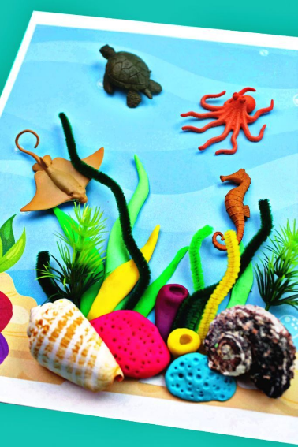Some brilliant coral reef-themed activity ideas can be found using the link below:  https://homeschool.rebeccareid.com/hands-on-coral-reef/ | PSHE:  Activities to Promote Emotional Well-Being  Connecting with Nature  Make your own paint brushes: All you need is some twigs, string (or a rubber band) and some materials for brushes (pine needles, leaves, grass or tree buds). Distribute the needles, leaves and grass around the stick and start attaching it by wrapping the rubber band (or string) around. Wrap the rubber band or string several times around the handle and the bristle material, then tie it firmly and cut off any excessive string. You’ve just made your very own brush!  Stone Pet  Find some interesting stones outdoors and create a stone pet.  https://www.redtedart.com/kids-crafts-matchbox-stone-pets/  Lead Chandelier  Make a leaf chandelier  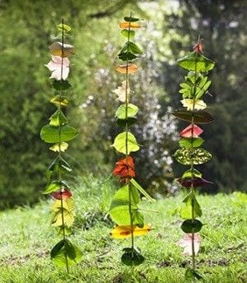 | DT / Food Tech  Topic:  To make foods connected to the sea, rivers or water. You might like  - Tuna mayo sandwich  - Sesame prawn toast  https://www.bbcgoodfood.com/recipes/sesame-prawn-toast  - Fish cakes  https://www.bbc.co.uk/food/recipes/easy_kids_fishcakes_70996  - Fish fingers  https://www.kidspot.com.au/kitchen/recipes/healthy-fish-fingers-recipe/x0oepe2r?r=collection/seafoodrecipes&c=iua0ofqr/Seafood%20recipes  - Tuna and Spinach Pancakes  https://www.bbcgoodfood.com/recipes/spinach-tuna-pancakes  - Tuna Pasta Bake  https://www.bbcgoodfood.com/recipes/tuna-sundried-tomato-pasta-bake  - Prawn Cocktail  https://www.eatsamazing.co.uk/seasonal-fun-food/christmas/easy-prawn-cocktail-recipe  - Prawn Tempura  https://www.netmums.com/recipes/prawn-tempura  - Fish Nuggets  https://www.tasteofhome.com/recipes/oven-fried-fish-nuggets/ | Music  Listening: Encourage your child to listen to a variety of music with a water theme and encourage them to describe what they hear in simple terms.  - Water Music by Handel  - The Sea by Debussy  - The Moldau by Smetana  - Spring Waters by Rachaninoff  - The River by Schubert  - Still Waters by Tony Banks  - Yellow River by Xinghai  Interacting/Performing:  Make your own musical instruments using water. http://kiddley.com/2013/07/09/10-great-musical-instruments-to-make-at-home/  Use musical instruments available at home / instruments you have made or household objects to create water-like sound effects.
Health and Fitness | A selection of Yoga stories to work through: https://www.youtube.com/user/CosmicKidsYoga  A Tai Chi sequence for children you might like to try with your child: https://www.youtube.com/watch?v=YMVg5diOiMs&t=428s  PE with Joe Wicks: https://www.youtube.com/watch?v=zKhGfdSvG3s  Daily walk.

