Squirrels Class-Week beginning 22nd June 2020
Suggestions of some home learning activities. Please feel free to adjust to suit your child.
Area of learning:
Literacy  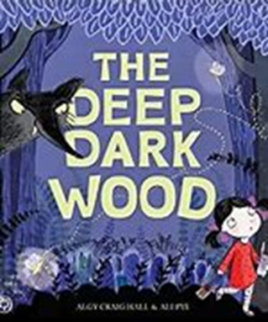 | Book: The Deep Dark Wood by Algy Craig Hall  PowerPoint book on the website  Shared reading: Follow the CAR (Comment and wait; Ask for participation and wait; Respond by adding a little more) and CROWD (Completion, Recall, Open-ended, Wh-, Distancing).  Shared writing:  Step 1:  Write a sentence about the book using the sentence starter: 'The wood is…' Take turns to write sentences. Write your name at the end of your sentence. Try to think about the letters in the word you want to spell.  Step 2:  Read through your sentences. 'The wood is' Look for your names at the end of your sentence. Try to think about the letters in your name.  Step 3:  Ask your child to cut up their sentences between each word. Or scan the sentence with a pair of scissors and look for any attempt your child makes to communicate they want to make a cut in the paper.  Step 4:  Ask your child to stick the words down in a sentence and see what order they stick them in. Model how you would read the sentence.  Step 5:  Cut up the sentences you wrote and see if you can order them. Stick them in your book. Talk about how the sentences should sound.  Independent writing: Use your alternative pencil to write about something you are interested in and your name. Adults to present whole alphabet and go through letters one at a time, using a flipchart, PODD book or alphabet letters. Any attempt to select any letter of the alphabet is praised and encouraged and recorded by the adult/partner.  Independent reading: Choose a book of your choice and look at the pictures, Comment on the pictures and words. Turn the pages one at a time. Oxford Owl or Reading Eggs have some free e-books. Lilac band of Oxford Reading Tree are the ones we use the most.  Letters of the day: G, F, D, Q and V. Focus on one letter a day. Use the Bounce Patrol videos to reinforce the letter.  Letter work: Use tactile letters.  Ideally, your letter sets can be displayed as the full alphabet, in alphabet order. When you focus on individual letters, ensure your child can see you select the letters from the full set to develop their understanding of the alphabetic principle. Your tactile letters might be plastic manipulatives, magnets, blocks, sandpaper letter cards.
Maths  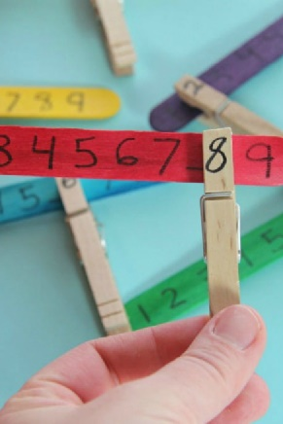 | - Boardmaker Online activities and Number songs  - Use the numicon and number line to count objects around the house/garden  - Functional maths skills at home  - Ideas for Maths Outdoors  - Try some free number games on abcya.com-https://www.abcya.com/grades/prek/numbers  - Read the maths story-Rosie’s walk on the website.  - Play a simon says game-using the positional language. E.g. ‘Simon says put your hands on your head’  - Use pegs and lollipop sticks to do some number matching. Practice your fine motor skills by clipping the peg onto the same number.
Science  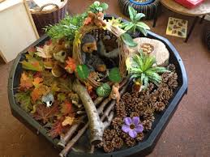 | Topic: Habitats  Intent: Pupils explore and identify the woodland habitat and identify woodland animals and their homes  - Experience different textures of Woodland floor; rustling leaves, bumpy wood  - Go on a scavenger hunt for leaves/plants/trees  - Sort animals into those you would expect to find in woodland and those you would not (Woodland sorting activity on Boardmaker Online)  - Match the names of woodland animals to their picture
PSHE | Topic: Living in the Wider World-Saving our planet  - Read the George saves the world story book on YouTube- https://www.youtube.com/watch?v=i6xdwpgFWd0  - Predictable Chart Writing- ‘Our world is….’  - Plant some vegetables and watch them grow (cress, lettuce, tomatoes). Maybe you could have them for dinner when they have grown.
PE  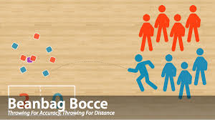 | Topic: Athletics  - Throwing for accuracy games- play beanbag boccia. Use beanbags or weighted balls. Throw one and see where it lands. Then throw the others. Try to get them as close as possible to the first beanbag/ball.
Art  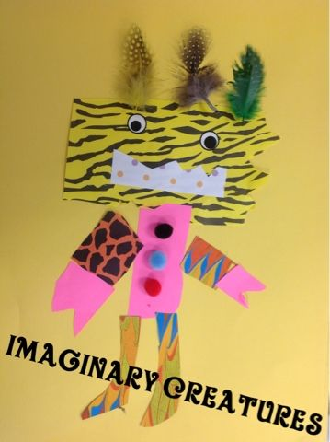 | Topic: Imaginary Places  Design and create your own giant imaginary creatures using any resources you have available
Music | Topic: Composition  - Watch kids Zumba. Copy all the moves. Move to the beat with your head or hands.  - Explore a range of composed music through a loud speaker and encourage pupils to choose an instrument using AAC so pupils can respond to the music with simple instruments.  - Develop a piece of music using the website. Composing website-https://www.classicsforkids.com/games/compose_your_own_music.php

Suggested Timetable
Monday | Tuesday | Wednesday | Thursday | Friday
Literacy | Literacy | Literacy | Literacy | Literacy
Maths | Maths | Maths | Maths | Maths
Science | Art | PE | PSHE | Music

