Squirrels Class-Week beginning 20th July 2020
Suggestions of some home learning activities. Please feel free to adjust to suit your child.
Area of learning:
Literacy  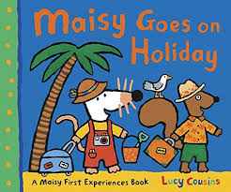  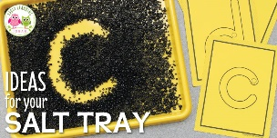 | Book: Maisy Goes on Holiday by Lucy Cousins  Powerpoint book on website  Shared reading: Follow the CAR (Comment and wait; Ask for participation and wait; Respond by adding a little more) and CROWD (Completion, Recall, Open-ended, Wh-, Distancing).  Shared writing:  Step 1:  Write a sentence about the book using the sentence starter: 'On Holiday, I will …' Take turns to write sentences. Write your name at the end of your sentence. Try to think about the letters in the word you want to spell.  Step 2:  Read through your sentences. 'On Holiday, I will…' Look for your names at the end of your sentence. Try to think about the letters in your name.  Step 3:  Ask your child to cut up their sentences between each word. Or scan the sentence with a pair of scissors and look for any attempt your child makes to communicate they want to make a cut in the paper.  Step 4:  Ask your child to stick the words down in a sentence and see what order they stick them in. Model how you would read the sentence.  Step 5:  Cut up the sentences you wrote and see if you can order them. Stick them in your book. Talk about how the sentences should sound.  Independent writing: Use your alternative pencil to write about something you are interested in and your name. Adults to present whole alphabet and go through letters one at a time, using a flipchart, PODD book or alphabet letters. Any attempt to select any letter of the alphabet is praised and encouraged and recorded by the adult/partner.  Independent reading: Choose a book of your choice and look at the pictures, Comment on the pictures and words. Turn the pages one at a time. Oxford Owl or Reading Eggs have some free e-books. Lilac band of Oxford Reading Tree are the ones we use the most.  Letters of the day: O, P, Q. Focus on one letter a day. Use the Bounce Patrol videos to reinforce the letter.  Letter work: Fill a sensory tray with salt or flour and write the letters of the alphabet.
Maths  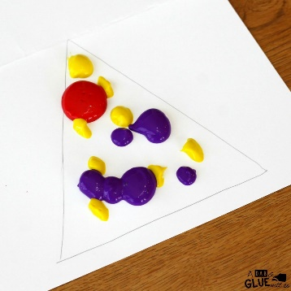  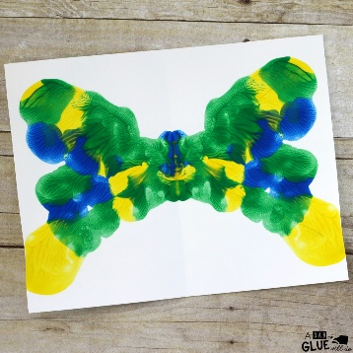 | - Symmetry Butterflies- Fold a piece of A4 card in half, paint on a triangle shape, fold the card over and push down. Look at your symmetrical butterfly.  - Parachute games-Find 5 monkey toys, sing 5 little monkeys jumping on the bed, throwing off a monkey each time.  - Use playdough and lollipop sticks to make different shapes. Talk about the shape you have made and the number of sides. How many sticks did you need? 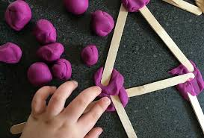
Arts and crafts  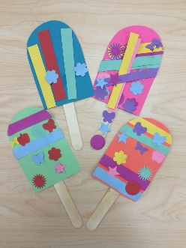 | Do some summer themed art;  - Make a sun collage using a paper plate and tissue paper  - Make a lollipop and use a lollipop stick  - Make a butterfly using a coffee filter or tissue paper  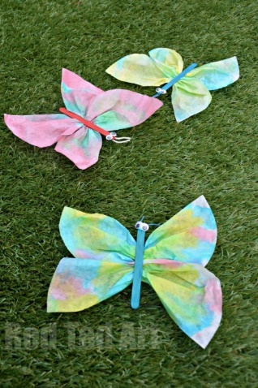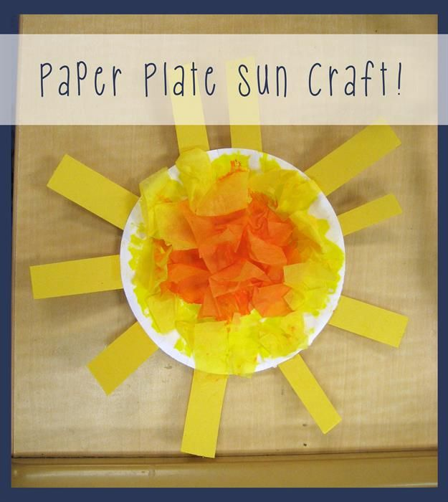
Food activities  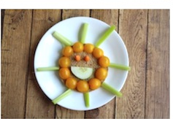  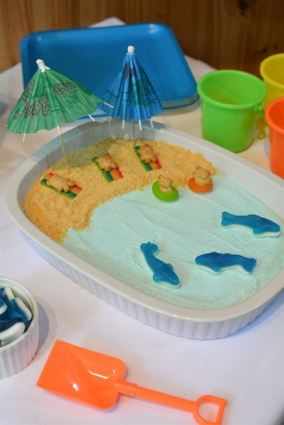 | Make some summer themed snacks;  - Sun- using rice cake, celery for rays, yellow fruit  - Beach landscape-using crumbled biscuits, yoghurt, animal biscuits  - Fruit kebabs  - Freeze slices of watermelon and make watermelon lollipops  

