Squirrels Class-Week beginning 15th June 2020
Suggestions of some home learning activities. Please, feel free to adjust to suit your child.
Area of learning:
Literacy  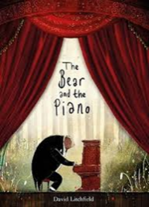 | Book: The Bear and the Piano by David Litchfield  Powerpoint book on website or YouTube video https://www.youtube.com/watch?v=ui8qayYnRWc  Shared reading: Follow the CAR (Comment and wait; Ask for participation and wait; Respond by adding a little more) and CROWD (Completion, Recall, Open-ended, Wh-, Distancing).  Shared writing:  Step 1:  Write a sentence about the book using the sentence starter: 'The city is...' Take turns to write sentences. Write your name at the end of your sentence. Try to think about the letters in the word you want to spell.  Step 2:  Read through your sentences. 'The city is...' Look for your names at the end of your sentence. Try to think about the letters in your name.  Step 3:  Ask your child to cut up their sentences between each word. Or scan the sentence with a pair of scissors and look for any attempt your child makes to communicate they want to make a cut in the paper.  Step 4:  Ask your child to stick the words down in a sentence and see what order they stick them in. Model how you would read the sentence.  Step 5:  Cut up the sentences you wrote and see if you can order them. Stick them in your book. Talk about how the sentences should sound.  Independent writing: Use your alternative pencil to write about something you are interested in and your name. Adults to present whole alphabet and go through letters one at a time, using a flipchart, PODD book or alphabet letters. Any attempt to select any letter of the alphabet is praised and encouraged and recorded by the adult/partner.  Independent reading: Choose a book of your choice and look at the pictures, Comment on the pictures and words. Turn the pages one at a time. Oxford Owl or Reading Eggs have some free e-books. Lilac band of Oxford Reading Tree are the ones we use the most.  Letters of the day: N, Y, W, K, P. Focus on one letter a day. Use the Bounce Patrol videos to reinforce the letter.  Letter games: Letter scavenger hunt-  Step 1: Select your target letter and display it.  Step 2: Explain the activity. “We are going on a letter hunt! Let’s find as many things as we can that start with the letter _!”  Step 3: Hunt for the letter! As you look around the physical space, notice objects and sound them out. “We are looking for things that start with the letter F. I see a flag! Ffff-lag! I hear an F! Lets take a picture of the flag!  Step 4: Try to find at least three things that start with that letter. Record what you find with photos or videos.  Step 5: Make a photo collage, or letter book with all the objects for that letter.
Maths | - Boardmaker Online activities and Number songs  - Use the numicon and number line to count objects around the house/garden  - Functional maths skills at home  - Ideas for Maths Outdoors  - Try some free number games on abcya.com-https://www.abcya.com/grades/prek/numbers  - Read the maths story-Rosie’s walk on the website.  - Play a hide and seek game. Put objects on, in, next to and under. Talk about positional language using PODD and toys and items you find in the house e.g. cups, bowls, boxes.  - Do some counting using numicon. Use the powerpoint on the website. Work on add 1 and add 2 and comment on what number you have now.
Science | Topic: Habitats  Intent: Pupils will explore and identify the key features of an underwater habitat  - Listen to sounds of dolphins/whales  - Taste salt water/fresh water  - Explore Underwater animals and toys in a water tray  - Under the sea bingo-see resources on website  - Compare sizes of sea creatures ie; blue whale, fish, crab-see resources on website
PSHE | Topic: Living in the Wider World-Saving our planet  - Read the George saves the world story book on YouTube- https://www.youtube.com/watch?v=i6xdwpgFWd0  - Predictable Chart Writing- ‘Our world is….’  - Design a superhero costume. Use the sheet on the website to design your own superhero costume or mask. Use colouring pencils, crayons, tissue paper and pom poms.
PE  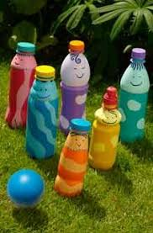 | Topic: Athletics  - Throwing games-Use some skittles and a ball to practise your throwing skills. Try to knock them all down. Record how many times it takes you to knock them all down.  - If you don’t have any skittles at home you could make some https://www.activityvillage.co.uk/make-your-own-skittles
Art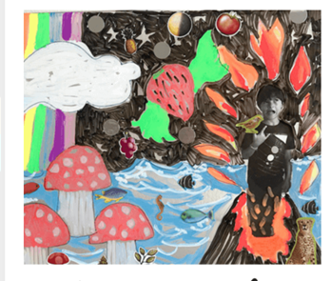 | Topic: Imaginary Places  - Create imaginary world using laminate sheet and your picture  - OR  - Use chalk drawings on the ground/black paper  - Think about what a world of your own would look like. Talk about your dream world. Ask questions about your dream world such as Which animals live there?, Is it cold?, Are there trees?, Does your world have flowers?, How about insects?, What do people eat? Etc.  Add stickers - Finally, bring out any fun stickers you may have around. Animals, insects, fairies, flowers and geometrical shapes.
Music | Topic: Composition  - Watch kids Zumba. Copy all the moves. Move to the beat with your head or hands.  - Watch and join in with clapping songs. Clap to the beat and increase the number of claps. Get faster and slower and try not to miss the beat. Use the clapping song below to make a rhythm. https://www.youtube.com/watch?v=anmcoVFcvc0  - Human orchestra game- pupils choose a sound/instrument. Respond to actions when teacher says go, stop, loud and quiet.

Suggested Timetable
Monday | Tuesday | Wednesday | Thursday | Friday
Literacy | Literacy | Literacy | Literacy | Literacy
Maths | Maths | Maths | Maths | Maths
Science | Art | PE | PSHE | Music

