Squirrels Class-Week beginning 8th June 2020
Suggestions of some home learning activities. Please, feel free to adjust to suit your child.
Area of learning:
Literacy  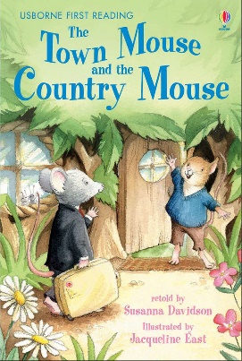 | Book: The Town Mouse and Country Mouse  https://www.bbc.co.uk/teach/school-radio/audio-stories-the-town-mouse-and-the-country-mouse/zrcrvk7 Audio or use the Powerpoint on website  Shared reading: Follow the CAR (Comment and wait; Ask for participation and wait; Respond by adding a little more) and CROWD (Completion, Recall, Open-ended, Wh-, Distancing).  Shared writing:  Step 1:  Write a sentence about the book using the sentence starter: 'I live in...' Take turns to write sentences. Write your name at the end of your sentence. Try to think about the letters in the word you want to spell.  Step 2:  Read through your sentences. 'I live in...' Look for your names at the end of your sentence. Try to think about the letters in your name.  Step 3:  Ask your child to cut up their sentences between each word. Or scan the sentence with a pair of scissors and look for any attempt your child makes to communicate they want to make a cut in the paper.  Step 4:  Ask your child to stick the words down in a sentence and see what order they stick them in. Model how you would read the sentence.  Step 5:  Cut up the sentences you wrote and see if you can order them. Stick them in your book. Talk about how the sentences should sound.  Independent writing: Use your alternative pencil to write about something you are interested in and your name. Adults to present one letter at a time, using a flipchart, PODD book or alphabet letters. Any attempt to select any letter of the alphabet is praised and encouraged and recorded by the adult/partner.  Independent reading: Choose a book of your choice and look at the pictures, Comment on the pictures and words. Turn the pages one at a time. Oxford Owl or Reading Eggs have some free e-books. Lilac band of Oxford Reading Tree are the ones we use the most.  Letters of the day: E, I, M, J, U. Focus on one letter a day. Use the Bounce Patrol link.  Letter games: Alphabet action-Provide the student with access to letters, preferably to the full alphabet. If you oﬀer the student a smaller set of letters, then ensure the student sees you select it from the full alphabet. “Hmm, which letters should we play with today? Let’s choose J (like you, Jordyn!) and M (like you, Max!)” Invite the child to select a letter. “Ella, pick a letter! Do you want J or M?” Oﬀer options of actions that start with that letter. “You picked J! That’s a fun letter! Hmm, actions that start with J. We could JUMP, JIGGLE, or JIVE! Which one should we do…JUMP…JIGGLE…JIVE….You clapped when I said JIGGLE so lets all get jiggling!!” Act it out! Teach kids that letters result in irresistible fun! Oﬀer new letters and start all over!
Maths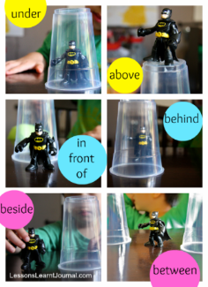 | - Boardmaker Online activities and Number songs  - Use the numicon and number line to count objects around the house/garden  - Functional maths skills at home  - Ideas for Maths Outdoors  - Play a ‘beat you to 10’ game using blocks and a dice. Roll the dice and count out that many blocks, then make a tower. Take turns to roll the dice. First person to 10 wins.  https://freeonlinedice.com/  - Talk about positional language using PODD and toys and items you find in the house e.g. cups, bowls, boxes.
Science | Topic: Habitats  Book: Rosie’s walk on website  - Listen to sounds of different animals  - Look at pictures/videos of different animals  - Match animal sounds to their pictures  - Play animal Snap-using animal toys or pictures
PSHE | Topic: Living in the Wider World-Saving our planet  - Read the George saves the world story book  - Do some Predictable Chart writing -‘Our world is….’  - Make a save the planet poster using pictures of the world
PE | Topic: Athletics  Try some more jumping. Use the sheet below for help.  https://www.youthsporttrust.org/sites/default/files/Home%20PE%20Standing%20Long%20Jump%202.pdf
Art | Topic: Imaginary Places  - Listen to music and paint the places you see in your mind  https://www.youtube.com/watch?v=ueWuuZOWqik
Music | Topic: Composition  - Watch kids Zumba. Copy all the moves. Move to the beat with your head or hands  - Play musical statues-using the phrases ‘stop’ and ‘go’  - Give your child a choice of percussive instruments. Develop own percussive routines.

Suggested Timetable
Monday | Tuesday | Wednesday | Thursday | Friday
Literacy | Literacy | Literacy | Literacy | Literacy
Maths | Maths | Maths | Maths | Maths
Science | Art | PE | PSHE | Music

