Home Learning Week beginning 13/7/20
These are activities for the week you can pick and choose and do what you like when you like!
Literacy :
Working with words, letters and sounds
Our letters this week are:

R https://www.youtube.com/watch?v=gUSJeivdEH8&t=10s
S https://www.youtube.com/watch?v=uSVzk2pqWB4&t=11s
T https://www.youtube.com/watch?v=HHEqOLZ0hr4
U https://www.youtube.com/watch?v=nPJRhEV-kF8&t=2s
V https://www.youtube.com/watch?v=PA47cP88ySw&t=2s
Don’t forget to practise writing the letter and finding words beginning with the letter in PODD books/PODD devices/Eye gaze, or objects around the house.
Independent writing
You can use any photographs, pictures or objects that your child might find interesting as a stimulus for independent writing.
Use the alphabet page in their PODD books/PODD devices/Eye gaze or keyboard page to choose letters and create words or sentences about their chosen topic. Make sure that they choose letters to write their name on their work.

Book
We’re reading “How the birds got their colours,” this week Katie has done a video on the school website you can access it here:
https://woodlandssurrey.primarysite.media/playlist/books

Or it is on youtube https://www.youtube.com/watch?v=JtRHtCa6GZ8

Make an Alphabet Books About Things I Really, Really Like!

This week make a book about your favourite things to watch on Youtube or tv !
You can use paper and pen (and stick on photos or Google Images), book making apps such as Pictello or Book Creator, or online book making sites such as tarheelreader.org. You can also use cheap photo albums and put a small piece of paper on the photo that has the sentence.
1) Create a page for each of their favourites. You do not have to do the whole alphabet; just put the pages in alphabetical order. It is ok if the book only has four pages! The most important thing is that your child is learning that letter of the alphabet is important because it is used to write the name of this thing I love!
2) Read the books often. Reading can look like just looking at the photos and talking about the pictures, not reading the words on all the pages, or just flicking through to find your special favourite page!
3) When you read the books, use your child’s communication system to comment on the pages, talk about the pictures, or simply say ‘let’s turn the page for MORE’.
4) Talk about special letters during the day.

Art activities:
We will be doing thank you cards in school for the people that help us – maybe you would like to make a card for someone who helps you or one for the NHS?
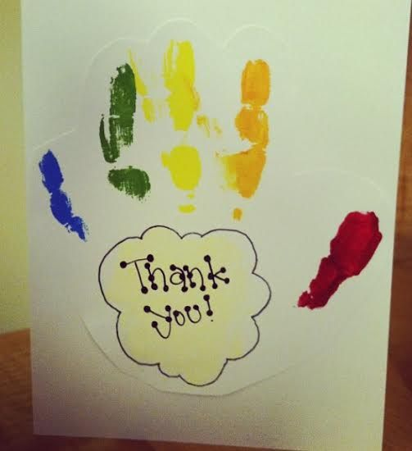

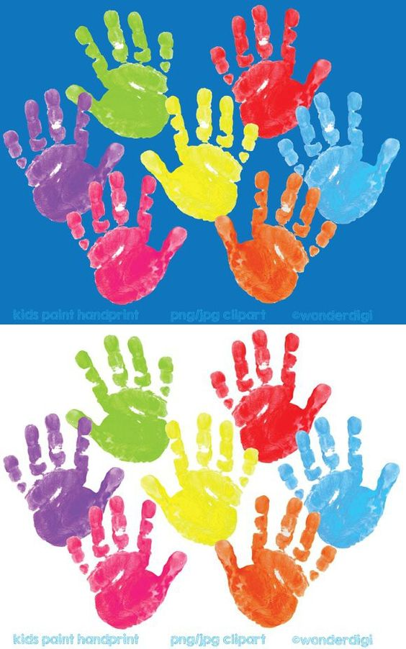
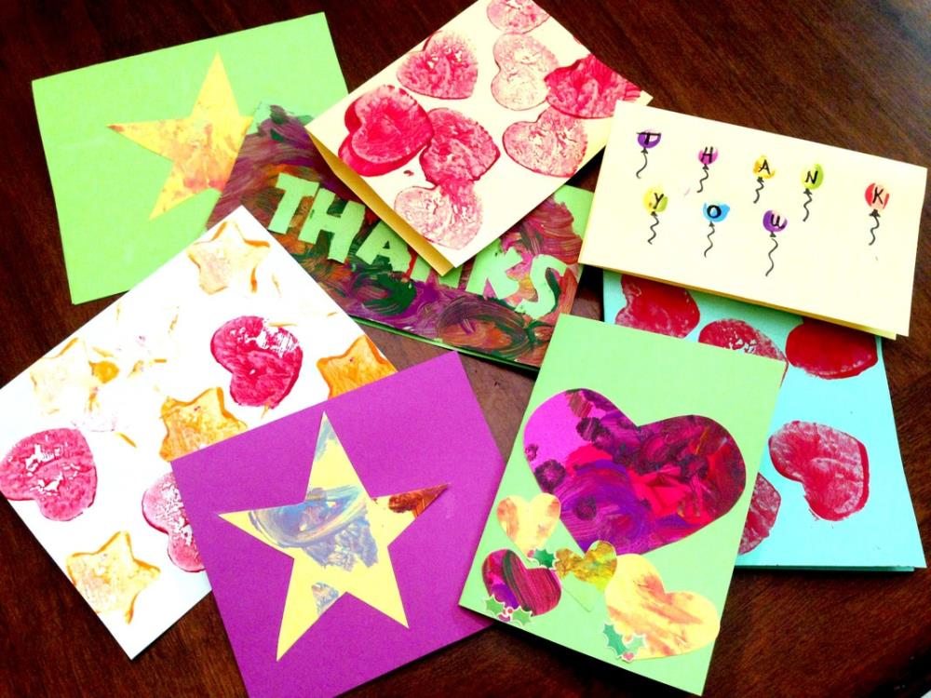
PSHE Activities

- To experience being part of a community
- .Cut out pictures of different people from magazines and glue onto a large collage (could go on a treasure hunt to find them dotted around the house/garden). Can you find lots of different types of people? Which are old and which are young? Are they all the same colour skin, hair, eyes? Are they all the same height? What jobs might they do? Do we think they are part of a family?

History Activities - Looking at homes in the past
This week we are looking at how bathrooms have changed
Go back in time with Magic Grandad !
https://www.youtube.com/watch?v=mRH_i655Vkw
Lots of opportunities for bubble baths/ water exploration here with sponges and flannels, bath toys etc
Explore coal tar soaps and shampoo, smell and feel.

PE Activities:
Warm up song https://www.youtube.com/watch?v=MugzDjGDYjo&t=16s

These are proving popular in school so thought you could try them again at home!
Move like an animal
You’ll need some open space, but this is a great way to use new muscles. Here are some ideas:
- Move like a bird (run with arms outstretched)
- Move like a snake (wiggle on tummies on the floor)
- Move like a bear (walk on all fours)
- Move like a frog (get down on haunches and hop)
- Move like a kangaroo (take big leaps with arms in front of chest)
- Move like an elephant (with heavy stomping)
- Move like a penguin (waddle with ankles close together and arms pinned to sides)
Need more ideas? https://lemonlimeadventures.com/animal-walks-sensory-diet/
Here are some great gross motor movements to try- time to get the music out!
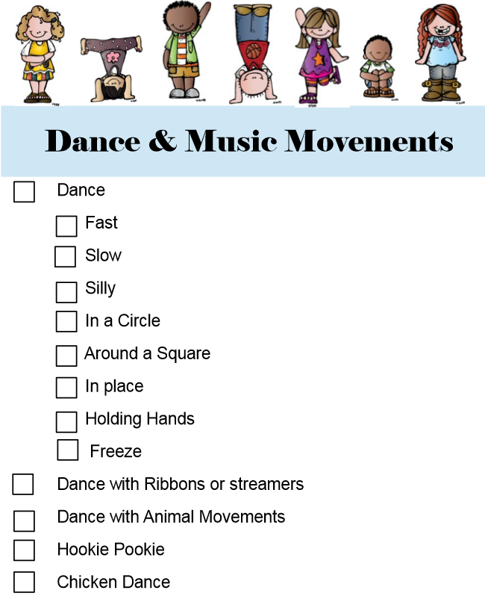

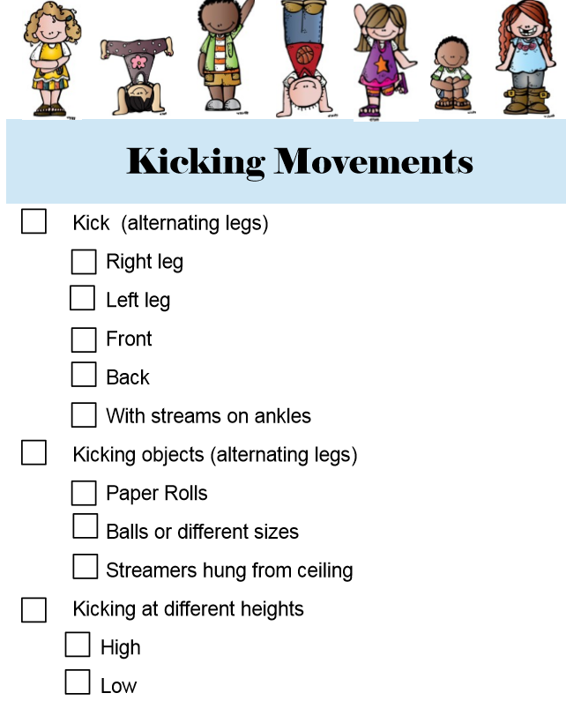

Maths activities
Please select one of the activities from both the ‘Functional Maths skills at home’ and ‘Ideas for Maths Outdoors’ sheets from your home learning pack

Sorting, counting, comparing activities
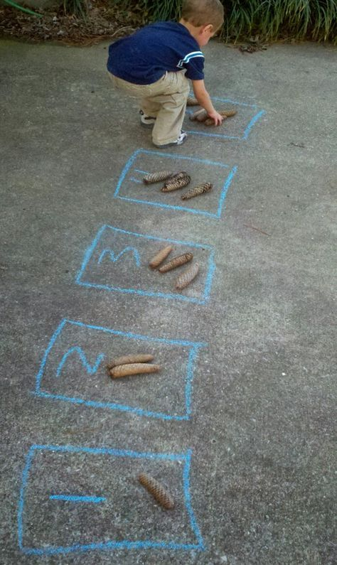
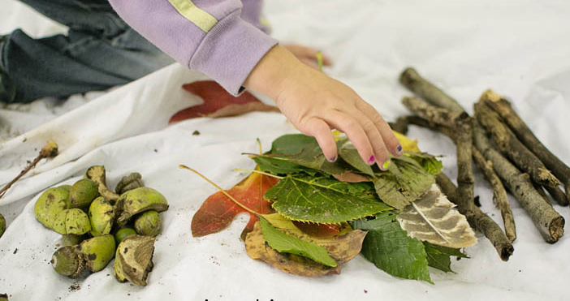
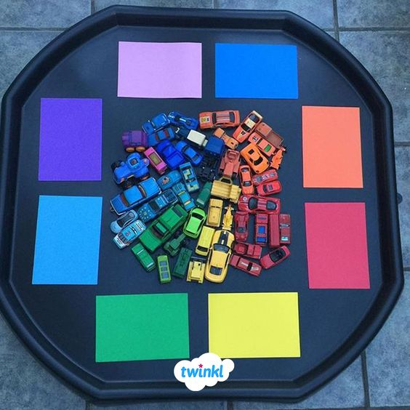
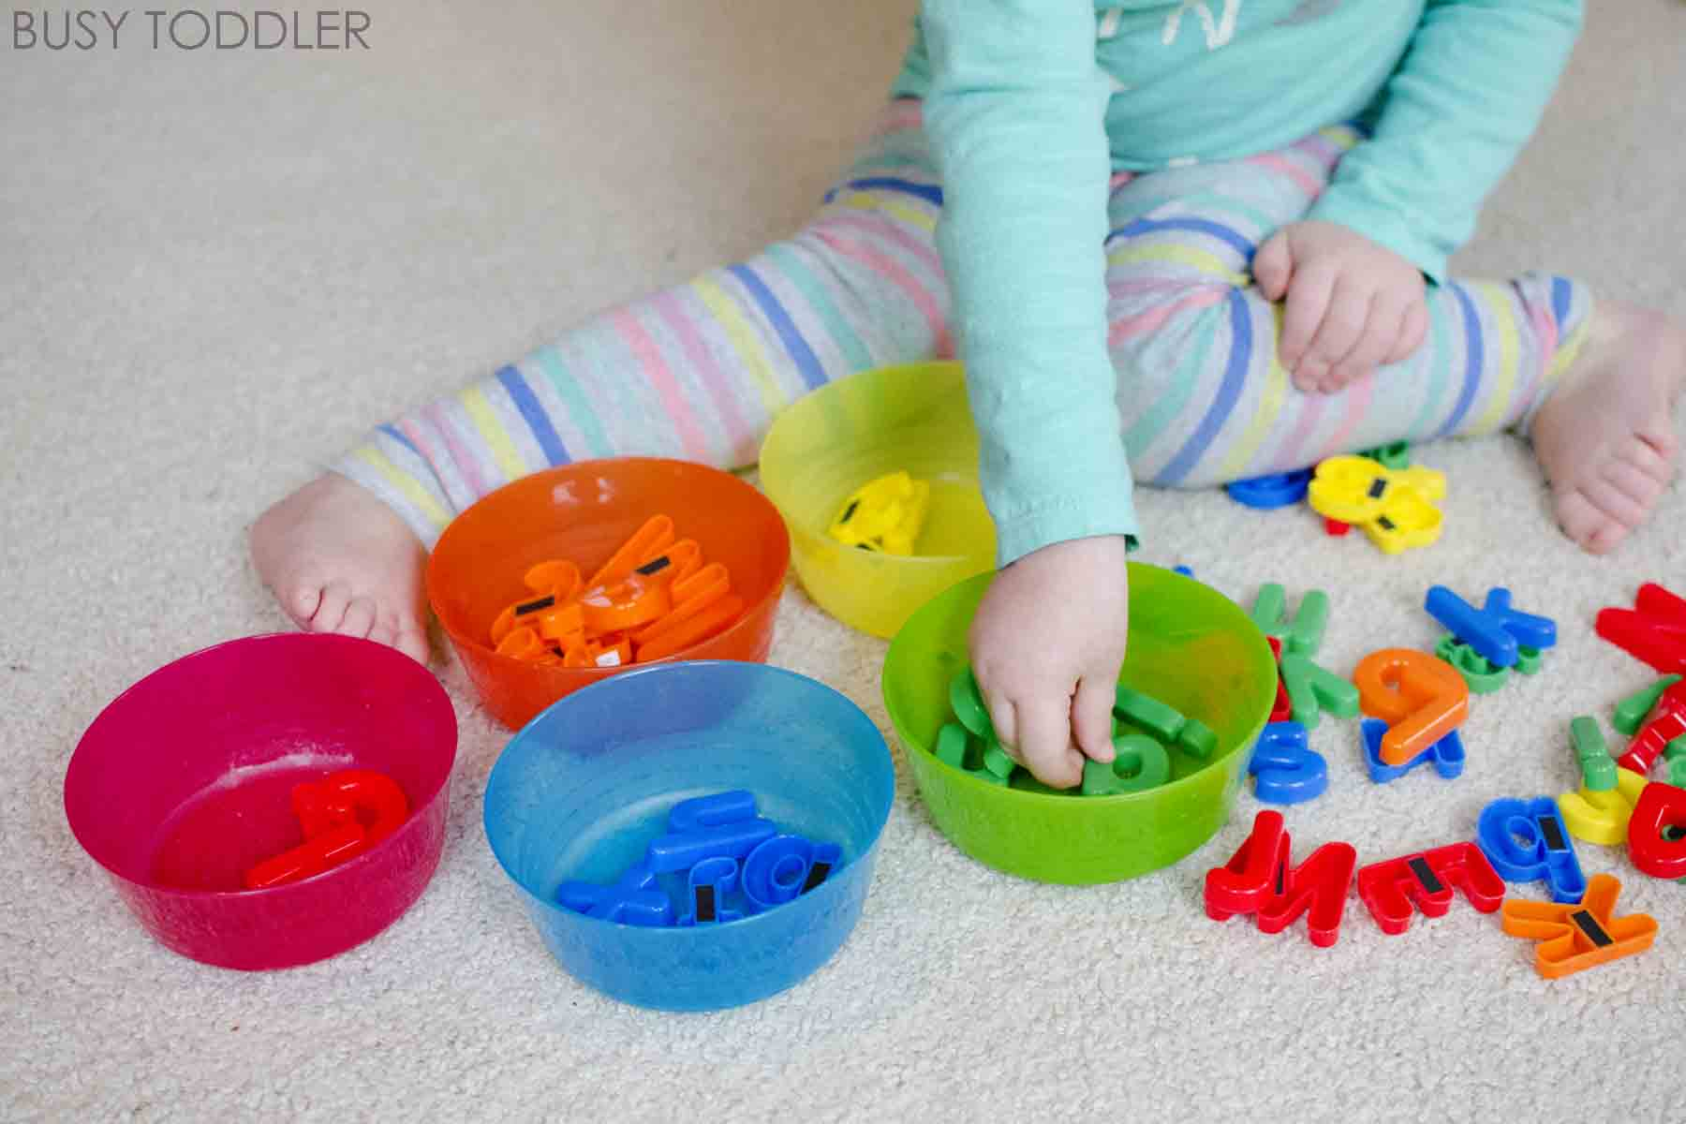
Take care. Have fun!

