Badgers Class: Week beginning 6th July 2020
Theme: Holidays Main focus: Camping holidays
Suggestions for this week’s home learning activities. Please feel free to do as much or as little as you would like.
Area of learning:
Communication & Language | Use our Holidays theme to extend vocabulary. Use a range of communication methods, such as objects of reference, touch cues, symbols, signs, PODD books and spoken language.  Attention Bucket: Use a variety of highly motivating toys to develop attention, turn taking, commenting and requesting.  See: https://woodlandssurrey.primarysite.media/media/bucket
Literacy | Shared reading: Little Kipper’s Sandcastle  Shared writing: Sentence starter: ‘Ice cream tastes…’ (This could be changed to ‘Ice lolly tastes…’  - Write the sentence starter at the top of the page  - Encourage children to select a symbol or look at the story to find something that describes the feel of sand. Use this to complete the sentence ‘Ice cream/Ice lolly tastes…’. If possible, give children some real ice cream or an ice lolly to taste.  - Each take a turn to identify something that describes the taste of ice cream/ice lolly (always beginning with the sentence starter, ‘Ice cream/Ice lolly tastes…’)  - When everyone has had a turn, read the sentences aloud.  Resources:  ‘Little Kipper’s Sandcastle’ PowerPoint in Badgers Home Learning section of Woodlands website.  ‘Tastes’ pdf in Badgers Home Learning section of Woodlands website (this has also been assigned to all pupils on their Boardmaker Online account).  Independent writing: Provide opportunities for independent mark making every day. Use a range of writing tools, e.g. pencils, chalk, crayons, paint, using fingers, etc.  Letters of the day (with links to Bounce Patrol song):  E: https://www.youtube.com/watch?v=beaUUPPUT2Y&t=9s  O: https://www.youtube.com/watch?v=oWbY5EKys60&t=12s  U: https://www.youtube.com/watch?v=nPJRhEV-kF8&t=2s  Y: https://www.youtube.com/watch?v=L8PdL8ydI28&t=2s  Q:https://www.youtube.com/watch?v=NKAookrRV4s&t=4s  Letter work: Explore the letters of child’s name in rice, sand, flour, etc. Encourage children to find the initial letter of their name.
Maths | - Number games at: https://www.topmarks.co.uk/maths-games/3-5-years  - 2D shapes - make a camping picture using 2D paper shapes:  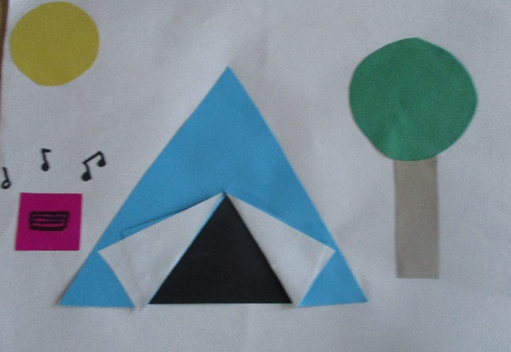
Understanding the World | Watch:  Mr Tumble camping video: https://www.yputube.com/watch?v=yBoe-MKFUJU  Topsy & Tim Camping story: https://www,youtube.com/watch?v=HOzmmKfACbY  A-Camping We Will Go song: https://youtube.com/watch?v=1Ha5nAQg-ys  Camping Out song: https://youtube.com/watch?v=B7zTkDgm3Ws
PSED | Work on independent feeding skills.  Work on dressing skills.  Work on toilet training.
Physical Development | Make a tent indoors or outside. Practise different ways of getting in and out of the tent, e.g. crawling in and out on hands and knees, commando crawling on tummy, rolling, etc.  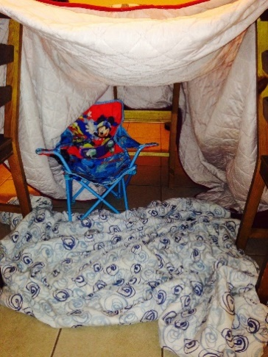
Expressive Arts and Design | Make a handprint campfire: cut some paper for logs, or use real sticks. Children to make yellow and red handprints for the flames.  

