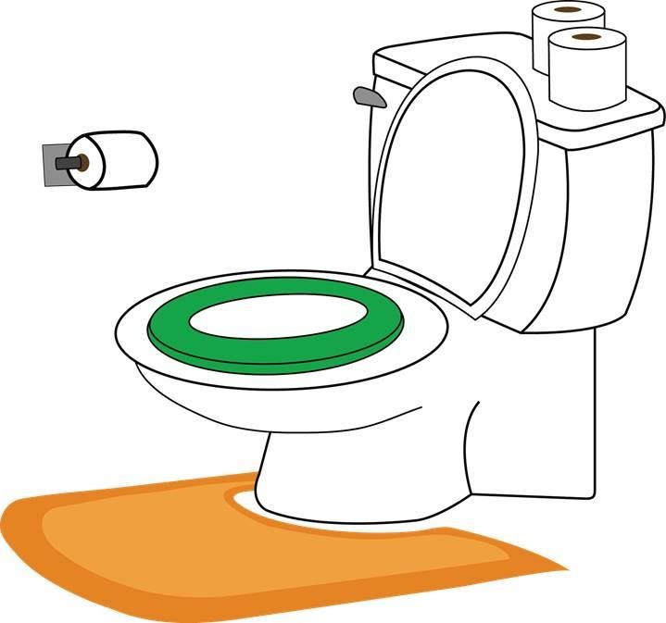

Toilet Training
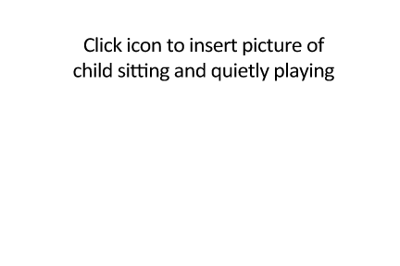Sometimes I need to wee or poo. I have a feeling in my body when I need to wee or poo.
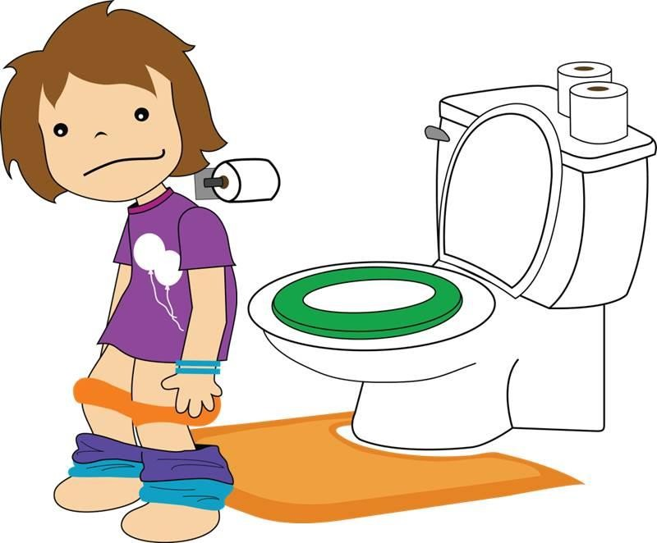When I feel like I have to wee or poo, I go to the bathroom. There I take down my pants and trousers.
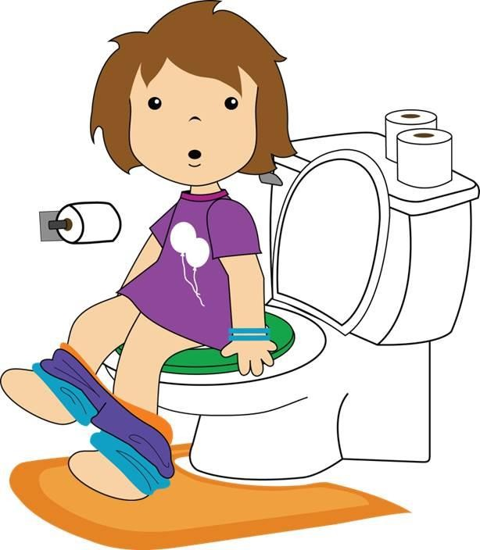I sit on the toilet. When I’m on the toilet I can go wee
or poo.
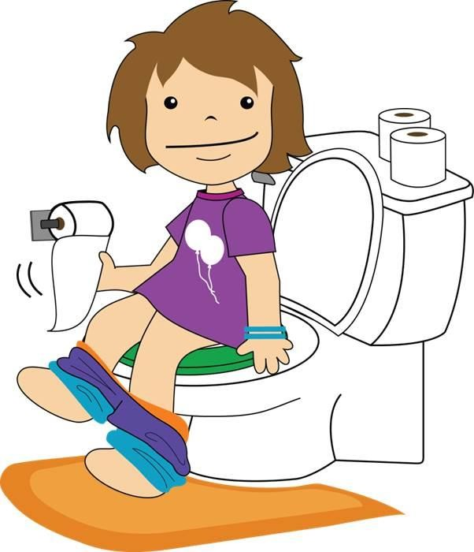After I make a poo in the toilet, I need to use toilet paper to wipe my bottom to keep my body clean. I can put the toilet paper in the toilet.
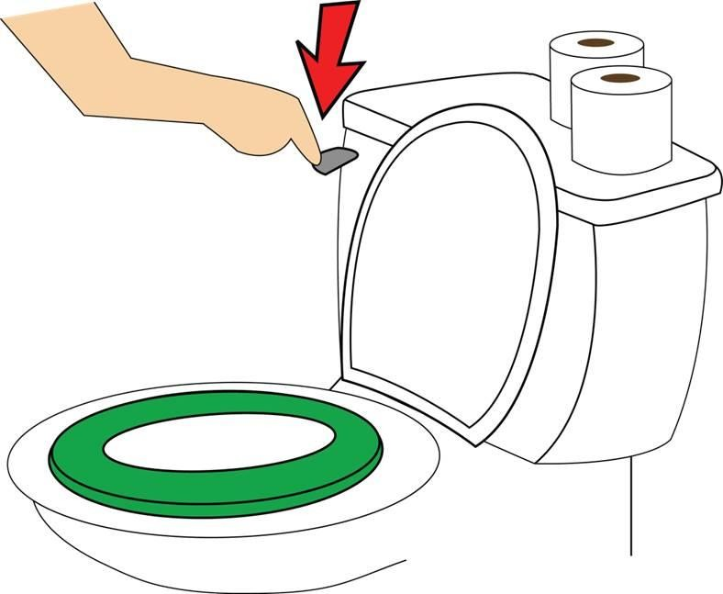After I pull my pants and underpants back up, I can flush the toilet.
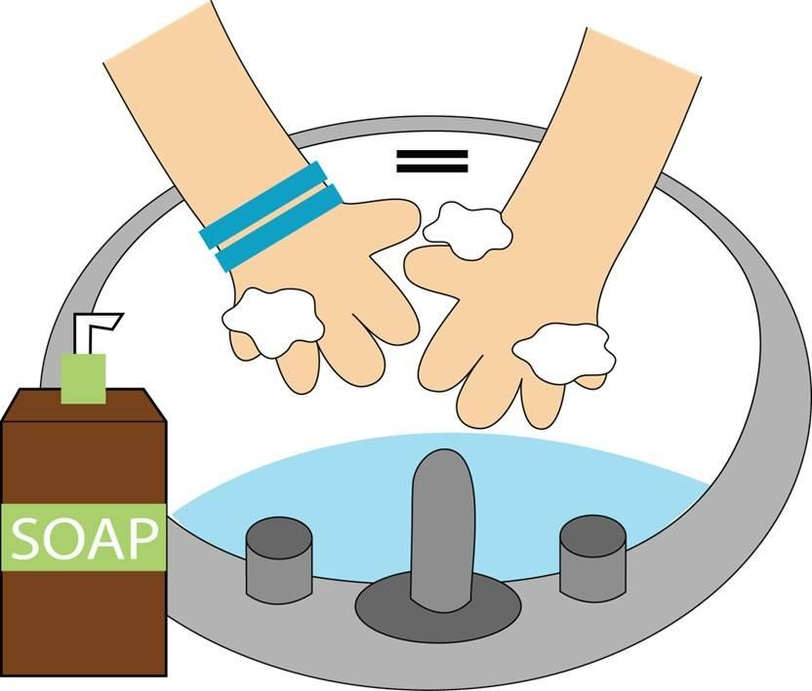After I wee or poo in the toilet, I need to wash my hands. Keeping my hands clean keeps me healthy.
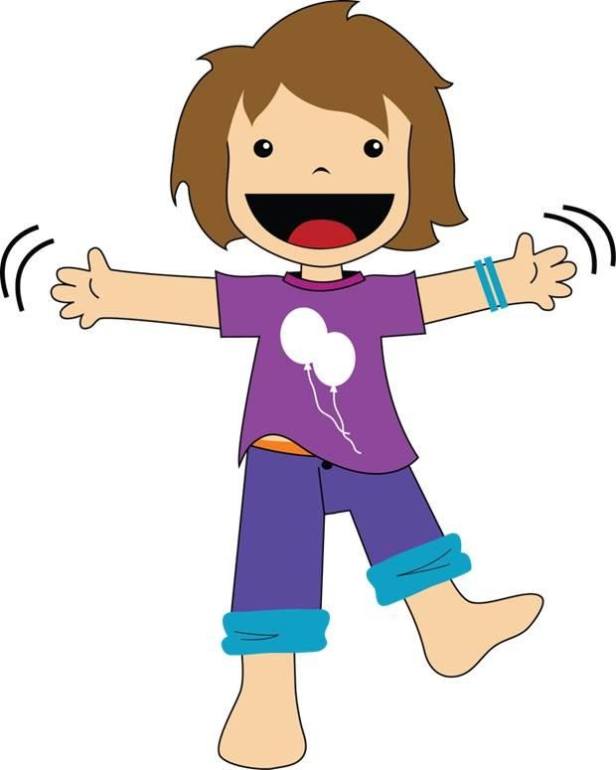When I go wee or poo in the toilet, I have clean underpants. That is great!
Sometimes I might have an accident. That is okay. I’ll
just keep practicing to make it to the toilet.
I can use the toilet. I’m so proud of myself!

